**CONNECTED HOME ENVIRONMENT MONITORING SYSTEM**

***AN INTERNSHIP REPORT***

***Submitted***

*In the partial fulfillment of the requirements for*

*the award of the degree of*

**Bachelor of Technology in**

**Electronics and Communication Engineering**

By

**N PRUDHVI REDDY**

Reg. No. 141FA05099

Under the guidance of Under the guidance of

Mr. Dhanasudakar Vasudevan, Ms. Ashline George

Mr. Vadamalai Ganesh Paramasivam Assistant professor

(Company Mentors)



**DEPARTMENT OF ELECTRONICS AND COMMUNICATION ENGINEERING**

**VIGNAN’S FOUNDATION FOR SCIENCE, TECHNOLOGY AND RESEARCH UNIVERSITY**

**VADLAMUDI, GUNTUR – 522 213, INDIA. NAAC ’A’ Accredited**

**May-2018**



**CERTIFICATE**

This is to certify that the internship report entitled **”CONNECTED HOME ENVIRONMENT MONITORING SYSTEM”** that is being submitted by **N PRUDHVI REDDY** bearing **141FA05099** in partial fulfilment for the award of B.Tech degree in Electronics and Communication Engineering to Vignan’s Foundation for Science Technology and Research University, is a record of bonafide work carried out by them at **Robert Bosch Engineering and Business Solutions Private Limited** under the supervision of **Dhanasudakar Vasudevan, Vadamalai Ganesh Paramasivam** and the internal guidance of **Ashline George** of ECE Department.

Signature of the faculty guide Signature of Head of the Department

Ms. Ashline George Mr. T. Pitchaiah Assistant Professor Assoc. Professor

**DECLARATION**

I hereby declare that the internship work entitled **“CONNECTED HOME ENVIRONMENT MONITORING SYSTEM”** is being submitted to Vignan’s Foundation for Science, Technology and Research, University, in partial fulfillment for the award of B.Tech degree in Electronics and Communication Engineering**.** The work was originally designed and executed by me under the guidance of my supervisor **Dhanasudakar Vasudevan,** **Vadamalai Ganesh Paramasivam** with **Ashline George** as faculty guide at Department of Electronics and Communication Engineering, Vignan’s Foundation for Science Technology and Research University and was not a duplication of work done by someone else. I hold the responsibility of the originality of the work incorporated into this thesis.

Signature of the candidate

N PRUDHVI REDDY

**ACKNOWLEDGEMENT**

Write briefly about Acknowledge the People whoever helped you in this regard hierarchically.

N **PRUDHVI REDDY**

|  |
| --- |
|  |

**TABLE OF CONTENTS**

**CHAPTER 1: INTRODUCTION Page No**

|  |  |  |
| --- | --- | --- |
| 1.1 | Motivation | 1 |
| 1.2 | Problem Definition | 2 |
| 1.3 | Objective of the Project | 3 |
| 1.4 | Limitations of Project | 5 |
| 1.5 | Organization of Documentation | 8 |

**CHAPTER 2: LITERATURE SURVEY**

|  |  |  |
| --- | --- | --- |
| 2.1 | Introduction | 12 |
| 2.2 | Existing System | 14 |
| 2.3 | Disadvantages of Existing System | 20 |
| 2.4 | Proposed System | 27 |
| 2.5 | Advantages over Existing System | 35 |

**CHAPTER 3: ANALYSIS**

|  |  |  |
| --- | --- | --- |
| 3.1 | Introduction | 40 |
| 3.2 | Software Requirement Specification | 41 |
| 3.3 | Content diagram of Project | 42 |

**CHAPTER 4: DESIGN**

|  |  |  |
| --- | --- | --- |
| 4.1 | Introduction/ General | 49 |
| 4.2 | ER/UML Diagrams | 51 |
| 4.3 | Module Design and Organization | 52 |
| 4.4 | Conclusion | 53 |

**CHAPTER 5: IMPLEMENTATION AND RESULTS**

|  |  |  |
| --- | --- | --- |
| 5.1 | Introduction | 73 |
| 5.2 | Implementation of key functions | 75 |
| 5.3 | Method of Implementation | 78 |
| 5.4 | Output Screens and Result Analysis |  |
| 5.5 | Conclusion |  |

**CHAPTER 6: TESTING AND VALIDATION**

|  |  |  |
| --- | --- | --- |
| 6.1 | Introduction | 73 |
| 6.2 | Design of Test cases and Scenarios | 75 |
| 6.3 | Validation | 78 |
| 6.4 | Conclusion |  |

**CONCLUSION**

**REFERENCES** 81

**LIST OF TABLES**

**Table Title Page**

|  |  |  |
| --- | --- | --- |
| 1.1 | Frequency of Application of Various Methodologies in Energy Policy Analysis (1973-1992 A.D.) | 8 |
| 1.2 | Percentage Share of Energy Consumption by Household  (Rural and Urban) Sector in India | 9 |
| 2.1 | Percentage Composition of Household (Rural and Urban) Energy Consumption in India | 34 |
| 2.2 | Annual Energy Consumption : Different End-user in  Urban India Households | 35 |

**LIST OF FIGURES**

**Figure Title Page**

1.1 Rate of energy consumption 9

1.2 Section-wise distribution of energy consumption 10

# **Chapter 1 Introduction**

Most of the people are conscious about the quality of 2-3 liters of water we drink every day. And of course, we care about the quality of our food?

But why are we not equally concerned about the quality of about 11,000 liters of air that we breathe every single day?

There are more than 8 million worldwide deaths per year from air pollution. But the deadly effects of air pollution aren’t new.

One can stay alive for weeks without food, for a few days without water, but not more than a few minutes without breathing. Now the question is: Breathing what? Air or with it, the Pollutants

As per a recent WHO report, India accounts for 1.3 million deaths annually due to indoor air pollution. Indoor air pollution is the second highest killer in India after [blood pressure](http://fatburningman.com/dr-william-davis-wheat-belly-going-gluten-free-why-grains-cause-heart-disease/), as per Global Burden of Diseases report.

We spend a majority of our time indoors- be it at home or office.

We cannot control the ambient air pollution, but we can take measures to curb the level of air pollution indoors. Hence, it is imperative that we pay attention to the quality of air we are breathing indoors.

You’re about to learn how one small change in your home can have a dramatic effect on your productivity, mental performance, and longevity.

When CO2 levels rise, your brain gives the signal to slow down. A fast computer chip becomes a slow chip and you reduce energy spending by way of brain power.

Carbon Monoxide poisoning is a risk with any gas solid fuel fires. Odorless, invisible and deadly, it is produced by a faulty appliance or if the flue is blocked. Breathing CO can cause headache, dizziness, vomiting, and nausea. If CO levels are high enough, you may become unconscious or die. Exposure to moderate and high levels of CO over long periods of time has also been linked with increased risk of heart disease.

A LPG gas explosion is an explosion resulting from mixing a gas, typically from a gas leak, with air in the presence of an ignition source. And LPG liquid forms cold burns when contacted with skin or eye. Inhaling LPG vapor at high concentration even for a short time can cause fainting and/or death. Inhaling of LPG vapor can cause irritation in nose and throat, headache and nausea, vomiting, dizziness and loss of consciousness.

Humidity affects human comfort, and the perceived temperature by humans is largely dependent upon atmospheric moisture content (Persinger, 1980). ... In the summer, high moisture content during hot periods can lessen the body's ability to evaporate perspiration, possibly leading to heat stress.

Exposure to extreme heat can lead to heat stroke and dehydration, as well as cardiovascular, respiratory, and cerebrovascular disease. Excessive heat is more likely to affect populations in northern latitudes where people are less prepared to cope with excessive temperatures.

When people burn wood, dung, coal, charcoal, gas, and crop wastes indoors for cooking or heating without good ventilation, smoke fills the house. This smoke contains harmful gases and tiny particulates that cause breathing problems and other illnesses. Headaches, dizziness, and fatigue are often followed by serious illnesses such as asthma, pneumonia, bronchitis, or lung cancer. Indoor air pollution from smoking fires also increases the [risk of getting TB](http://en.hesperian.org/hhg/A_Community_Guide_to_Environmental_Health:Indoor_Air_Pollution#Tuberculosis_.28TB.2C_consumption.29).

Women and children are the most exposed to harmful cooking smoke. When pregnant women are exposed to a lot of smoke every day, it can cause their children to be born very small, grow slowly, and have difficulty learning later on. In some cases, it can even cause children to be born dead.

For the deadly components of air like co, co2, smoke and the LPG gas, Temperature & Humidity of air we developed a device to detect them. Notification will be sent to the user through APP when the gases are at high and moderate level.

**1.1 Motivation**

The largest indoor concentrations of many important pollutants and the greatest exposure to these pollutants are found in rural areas in the developing world (Cheet al 1990). Eighty-five percent of all human particulate Exposure has been estimated to occur indoors, and 80% of this occurs in developing countries (Smith 1993a). Domestic smoke pollution due to combustion of biomass has been related to serious health effects. Acuteres piratory infection (ARI) is a chief cause of death invery young children, and the risk of ARI is significantly higher among children living in households using biomassas their main fuel (Pandey et al 1989). Indoor air pollution has also been connected to adverse pregnancy outcomes, lung cancer, chronic lung diseases, exacerbation of coronary artery disease, and eye problems.

**1.2 Problem definition**

Every Home Automation box is a stand-alone device. It is connected to mains and controls the power outlet of the electrical device that is plugged into it. There will a receiver and transmitter in each of the box, so they can exchange the information with a computer or mobile phone. People can control from any place. People can enjoy the high technology and simplicity modern life style. Each device will be with standard setup and while adding it into a network. This devices can kept in different rooms were we need them. Various different sensors are used as triggers for actions that user can set up in the program. We can control the temperatures of our house with a single device. And also we can able to make our home secure with a security camera.

**1.3 Objective of the project**

Energy Cost and IAQ Performance of Ventilation Systems and *Controls -* is part of

That effort. Adequate ventilation is a critical component of design and management practices needed for good indoor air quality. Yet, the energy required to run the ventilation system constitutes about half of a building’s energy cost. Since energy efficiency can reduce operating costs and because the burning of fossil fuels is a major source of greenhouse gases, energy efficiency has become an important concern to the building industry and the promotion of efficient energy utilization has become a matter of public policy. It is important, therefore, to examine the relationship between energy use and indoor air quality performance of ventilation systems. This project represents a substantial modeling effort whose purpose is to assess the compatibilities and trade-offs between energy, indoor air quality, and thermal comfort objectives in the design and operation of HVAC systems in commercial buildings, and to shed light on potential

Strategies which can simultaneously achieve superior performance on each objective.

**1.4 Limitations of project**

The process of investigating indoor air quality (IAQ) and energy use can be time-consuming and expensive. In order to streamline the process, this study employed a building simulation computer modeling procedure. The computer modeling approach enabled the investigation of multiple variations of building configurations and climate variations at a scale which would not otherwise be possible at considerably less cost than field study investigations. While a large number of building parameters were used to capture the relevant variations in the building stock and their ventilation systems, as a whole, they cannot be considered representative because of the exceptionally large variety building and ventilation system features which are currently available.

Knowledge and understanding of the inventory and performance of building equipment in the current building stock is limited, so that the ability to model representative variations in actual equipment performance is also limited. The modeling assumed that all equipment functioned as it was intended to function. Poor design, poor operations, and malfunctioning equipment, which are not uncommon in existing buildings, could not be directly modeled. For comparison purposes, the same buildings were modeled for each climate and does not reflect climatic differences in building construction.

# **Chapter 2 LITERATURE SURVEY**

The report gives results of a literature review, conducted to survey and summarize recent and ongoing engineering research into building ventilation, air exchange rate, pollutant distribution and dispersion, and other effects of heating, ventilation, and air-conditioning (HVAC) systems on indoor air quality (IAQ). He concerns of the ventilation community and technical questions that remain to be solved were identified, as were a number of research opportunities. he ventilation-related engineering literature was divided into seven major categories: (1) pollutant transport to and into the building envelope; (2) air cleaning systems; (3) flow and pollutant dispersion; (4) room and building flow/dispersion research; (5) HVAC/building design, operation, and control strategies; (6) applied microbial research; and (7) building performance. he significance and status of ventilation-related IAQ research was summarized by research category, and research opportunities were identified within each category.

**2.1 Introduction**

In this article, the authors summarize the results of field studies to evaluate the ventilation and indoor air quality performance in high-performance commercial (nonindustrial and nonresidential) buildings in North America. The authors show that the number of such studies is small and that the ventilation and indoor air quality measurements performed vary widely. For example, only one of the studies directly measured ventilation rates and one additional study used measured carbon dioxide concentrations to estimate these rates. Similarly, the suite of indoor pollutants measured, which generally included some measure of particulate matter and total volatile organic compounds, rarely included measurements of biological contaminants, semi-volatile organic compounds, or ozone. Previously published concepts are discussed for documenting indoor air quality in high-performing buildings during design, construction and commissioning, and after occupancy, and conclude more complete and uniform studies are needed on the economic, environmental, and health implications of ventilation and indoor air quality in high-performance commercial buildings.

**2.2 Existing system**

Indoor air quality (IAQ) is a term which refers to the [air quality](https://en.wikipedia.org/wiki/Air_quality) within and around [buildings](https://en.wikipedia.org/wiki/Building) and [structures](https://en.wikipedia.org/wiki/Structure), especially as it relates to the health and comfort of building occupants. IAQ can be affected by gases (including [carbon monoxide](https://en.wikipedia.org/wiki/Carbon_monoxide), [radon](https://en.wikipedia.org/wiki/Radon), [volatile organic compounds](https://en.wikipedia.org/wiki/Volatile_organic_compound)), [particulates](https://en.wikipedia.org/wiki/Atmospheric_particulate_matter), [microbial](https://en.wikipedia.org/wiki/Microorganism) contaminants ([mold](https://en.wikipedia.org/wiki/Mold), [bacteria](https://en.wikipedia.org/wiki/Bacteria)), or any mass or energy stressor that can induce adverse health conditions. Source control, filtration and the use of [ventilation](https://en.wikipedia.org/wiki/Ventilation_%28architecture%29) to dilute contaminants are the primary methods for improving indoor air quality in most buildings. Residential units can further improve indoor air quality by routine cleaning of carpets and area rugs.

Determination of IAQ involves the collection of air samples, monitoring human exposure to pollutants, collection of samples on building surfaces, and computer modelling of air flow inside buildings.

IAQ is part of [indoor environmental quality](https://en.wikipedia.org/wiki/Green_building#Indoor_environmental_quality_enhancement) (IEQ), which includes IAQ as well as other physical and psychological aspects of life indoors (e.g., lighting, visual quality, acoustics, and thermal comfort).

[Indoor air pollution in developing nations](https://en.wikipedia.org/wiki/Indoor_air_pollution_in_developing_nations) is a major health hazard. A major source of indoor air pollution in developing countries is the burning of [biomass](https://en.wikipedia.org/wiki/Biomass) (e.g. wood, charcoal, dung, or crop residue) for heating and cooking. The resulting exposure to high levels of particulate matter resulted in between 1.5 million and 2 million deaths in 2000.

**2.3 Disadvantages of Existing system**

In spite of the relief it brings on a hot sunny day, there are some health problems which occurs due to the 24/7running of air conditioning. The following are some of the Disadvantages of Air Conditioner on Health.

* Unexpected changes in humidity & temperature affects individual’s respiratory system
* Regular usage of air Conditioner dries skin & mucous membranes
* Its ambient noise, leads to noise pollution.
* Air circulation even transmits infectious respiratory diseases
* Airborne dust & fungi cause allergic reactions
* Air conditioning is related with chronic rhinitis & pharyngitis, hoarseness and throat irritation
* Air conditioning can worsen eye conditions like conjunctivitis & blepharitis, and alos results in causing problems for contact lens wearers.
* Sometimes indoor air pollution is greater than outdoor air pollution. If indoor air contains allergens, you may suffer from nasal issues, headache, itchy eyes, difficulty breathing and dizziness. In extreme cases, pneumonia and [asthma](http://www.plus100years.com/what-are-some-breathing-techniques-for-asthma/) attacks can also develop.
* Spending long hours in air conditioned of offices or home you may cause also suffer heat intolerance when you go outside.
* If you suffer from allergies in the summer months, running air conditioning constantly worsen your symptoms if AC system has not been regularly maintained.

**2.4 Proposed System**

In this project, we are going to be using a Raspberry Pi 3 (Fig:1) is a low cost, credit-card sized computer that plugs into a computer monitor or TV, and uses a standard keyboard and mouse, it is a capable little device that enables people of all ages to explore computing

Objective of this project is to connect home Environment. Our device will able to detect different types of Gases like carbon dioxide, oxygen, LPG in Home. Home temperature will also be detect by this device If the temperature level Exceeds then it will give a notification.

When an person visits the home as the door bell is rung by him/her and picture of that person will be snapped immediately ,which can be viewed through an app or mail services When some motion is detected by the web camera then picture will be snapped.

**Features:**

Motion detection and photo capture using the camera.

Mobile notifications with photos.

# **Chapter 3 ANALYSIS**

There are many sources of indoor air pollutants; one of the most common sources is environmental tobacco smoke emitted from the burning of tobacco products. Environmental tobacco smoke is one of the major issues discussed among researchers in Malaysia that directly affect the indoor air in the office.3 Beside environmental tobacco smoke, other various chemical substances may directly influence the quality of air served by an MVAC system, eg, volatile organic compounds emitted from the use and application of solvents, ozone emitted from photocopiers and laser printers, and formaldehyde emitted from furnishings.

In recent years, many occupational health and safety (OSH) professionals have been aware of, and concerned about, the IAQ issues in their nonindustrial workplace. However, a challenge arose when OSH professionals had difficulty in “predetermining” the air quality served by MVAC. The ICOP-IAQ standard was drawn up to ensure that employees and occupants are protected from poor IAQ that could adversely affect their health and wellbeing and thereby reduce their productivity. As stipulated under section 15 of the Malaysian OSH Act 1994, the code (ICOP-IAQ) functions as the general duties of employers and self-employed persons to their employees; however, section 17 stipulates that it is also the general duties of employers and self-employed persons to persons other than their employees. Based on this justification, some difficulties and challenges arose for OSH professionals in regards to determining whether or not their building is healthy.

**3.1 Introduction**

To analyze and characterize a multidisciplinary, integrated indoor air quality checklist for evaluating the health risk of building occupants in a nonindustrial workplace setting. A modified version of the indoor environmental checklist published by the Department of Occupational Health and Safety, based on the literature and discussion with occupational health and safety professionals, was used in the evaluation process. Summated scores were given according to the cluster analysis and principal component analysis in the characterization of risk. Environmetric techniques was used to classify the risk of variables in the checklist. Identification of the possible source of item pollutants was also evaluated from a semi quantitative approach.

Hierarchical agglomerative cluster analysis resulted in the grouping of factorial components into three clusters (high complaint, moderate-high complaint, moderate complaint), which were further analyzed by discriminant analysis. From this, 15 major variables that influence indoor air quality were determined. Principal component analysis of each cluster revealed that the main factors influencing the high complaint group were fungal-related problems, chemical indoor dispersion, detergent, renovation, thermal comfort, and location of fresh air intake. The moderate-high complaint group showed significant high loading on ventilation, air filters, and smoking-related activities. The moderate complaint group showed high loading on dampness, odor, and thermal comfort.

**3.2 Software Requirement Specification**

* Raspbian
* Java JDK
* Emulator
* Android studio

Raspbian

Raspbian is the recommended operating system for normal use on a Raspberry Pi. Raspbian is a free operating system based on Debian, optimized for the Raspberry Pi hardware. Raspbian comes with over 35,000 packages: precompiled software bundled in a nice format for easy installation on your Raspberry Pi.Raspbian is a community project under active development, with an emphasis on improving the stability and performance of as many Debian packages as possible.

Java JDK

The JDK and the JRE have minimum processor, disk space, and memory requirements for 64-bit Windows platform.

Before installing the JDK or the JRE on your 64-bit Windows platform, you must verify that it meets the following minimum processor, disk space, and memory requirements.

Processor Requirements

Both the JDK and JRE require at least minimum of Pentium 2.266 MHz processor.

Disk Space Requirements

For JDK 9, you are given the option of installing the following features:

* Development Tools
* Source Code
* Public Java Runtime Environment

When you install 64-bit JDK, then 64-bit public JRE also gets installed. The following table provides the disk requirements for the installed features:

For any text in this document that contains the following notation, you must substitute the appropriate update version number:

minor.security.patch

For example:

* If you are downloading the JDK installer for 64-bit systems for update 9 Minor 1, Security 1, and Patch 1, then the file name jdk-9.minor.security.patch_windows-x64_bin.exe becomes jdk-9.1.1.1_windows-x64_bin.exe.
* If you are downloading the JRE installer for 64-bit systems for update 9 Minor 1, Security 1, and Patch 1, then the file name jre-9.minor.security.patch_windows-x64_bin.exe becomes jre-9.1.1.1_windows-x64_bin.exe

Emulator

In [computing](https://en.wikipedia.org/wiki/Computing), an emulator is hardware or software that enables one computer system (called the *host*) to behave like another computer system (called the *guest*). An emulator typically enables the host system to run software or use peripheral devices designed for the guest system. Emulation refers to the ability of a [computer program](https://en.wikipedia.org/wiki/Computer_program) in an electronic device to emulate (or imitate) another program or device. Many [printers](https://en.wikipedia.org/wiki/Computer_printer), for example, are designed to emulate [Hewlett-Packard](https://en.wikipedia.org/wiki/Hewlett-Packard) [LaserJet](https://en.wikipedia.org/wiki/LaserJet) printers because so much software is written for HP printers. If a non-HP printer emulates an HP printer, any software written for a real HP printer will also run in the non-HP printer emulation and produce equivalent printing. Since at least the 1990s, many [video game](https://en.wikipedia.org/wiki/Video_game) enthusiasts have used emulators to play classic (and/or forgotten) [arcade games](https://en.wikipedia.org/wiki/Arcade_game) from the 1980s using the games' original 1980s programming code, which is interpreted by a current-era system.

A hardware emulator is an emulator which takes the form of a hardware device. Examples include the DOS-compatible card installed in some 1990s-era [Macintosh computers](https://en.wikipedia.org/wiki/Macintosh_computer) like the [Centris 610](https://en.wikipedia.org/wiki/Centris_610) or [Performa 630](https://en.wikipedia.org/wiki/Performa_630) that allowed them to run [personal computer](https://en.wikipedia.org/wiki/Personal_computer) (PC) software programs and [FPGA](https://en.wikipedia.org/wiki/Field-programmable_gate_array)-based [hardware emulators](https://en.wikipedia.org/wiki/Hardware_emulation). In a theoretical sense, the [Church-Turing thesis](https://en.wikipedia.org/wiki/Church-Turing_thesis) implies that (under the assumption that enough memory is available) any operating environment can be emulated within any other environment. However, in practice, it can be quite difficult, particularly when the exact behavior of the system to be emulated is not documented and has to be deduced through [reverse engineering](https://en.wikipedia.org/wiki/Reverse_engineering). It also says nothing about timing constraints; if the emulator does not perform as quickly as the original hardware, the emulated software may run much more slowly than it would have on the original hardware, possibly triggering timer interrupts that alter behavior.

Android studio

**Installation of Android Studio:-**

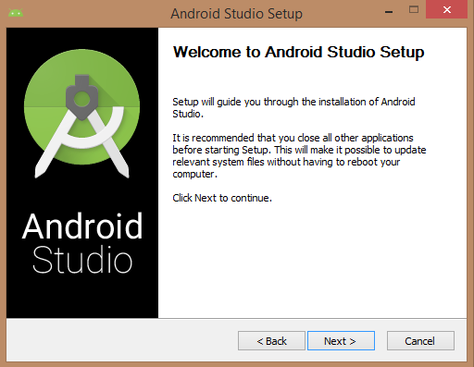

* Once you launched Android Studio, it’s time to mention JDK7 path or later version in android studio installer.

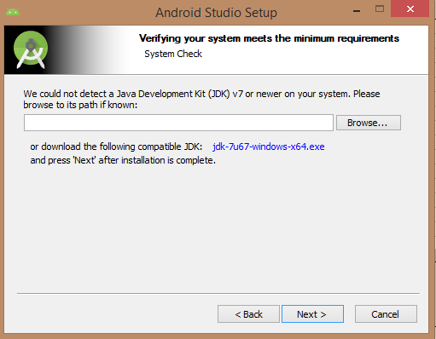

* Below the image initiating JDK to android SDK

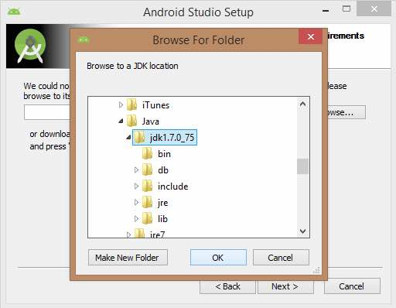

* Need to check the components, which are required to create applications, below the image has selected Android Studio, Android SDK, Android Virtual Machine and performance (Intel chip).

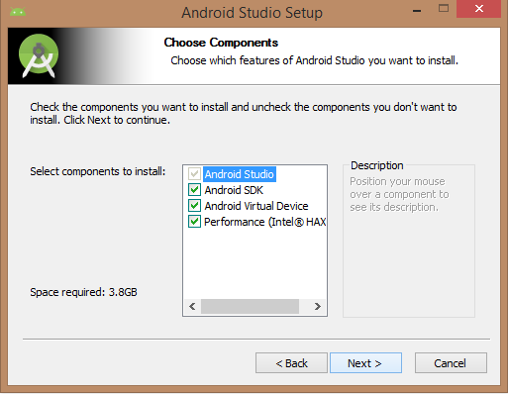

* Need to specify the location of local machine path for Android studio and Android SDK, below the image has taken default location of windows 8.1 x64 bit architecture.

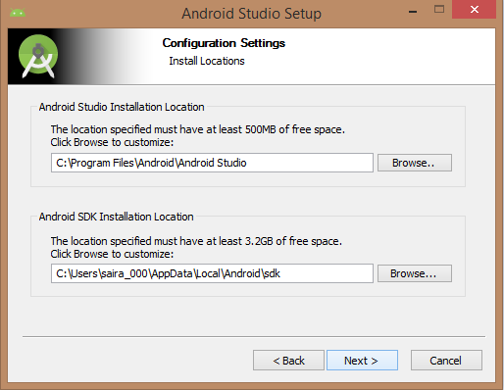

* Need to specify the ram space for Android emulator by default it would take 512MB of local machine RAM.

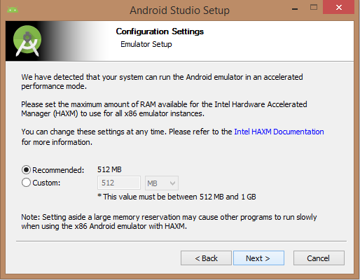

* At final stage, it would extract SDK packages into our local machine, it would take a while time to finish the task and would take 2626MB of Hard disk space.

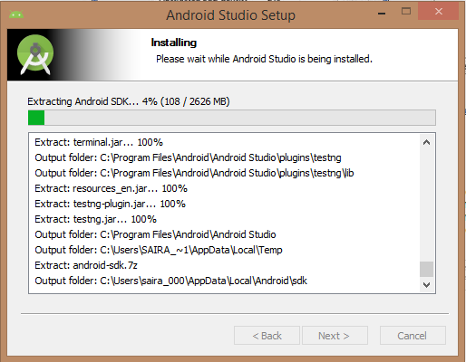

* After done all above steps perfectly, you must get finish button and it gonna be open android studio project with Welcome to android studio message as shown below

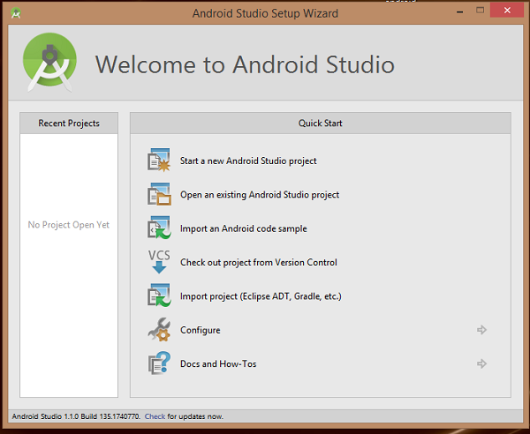

* You can start your application development by calling start a new android studio project. In a new installation frame should ask Application name, package information and location of the project.

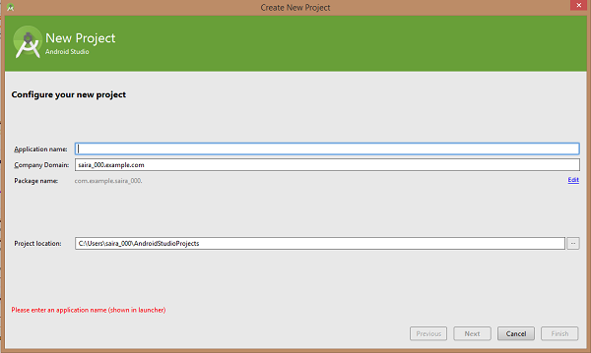

* After entering application name, it going to be called select the form factors your application runs on, here need to specify Minimum SDK, in our tutorial, I have declared as API23: Android 6.0(Marshmallow)

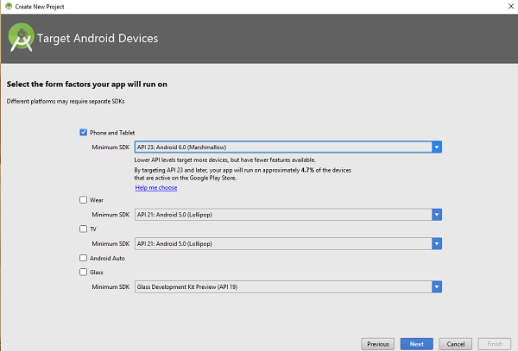

* The next level of installation should contain selecting the activity to mobile, it specifies the default layout for Applications

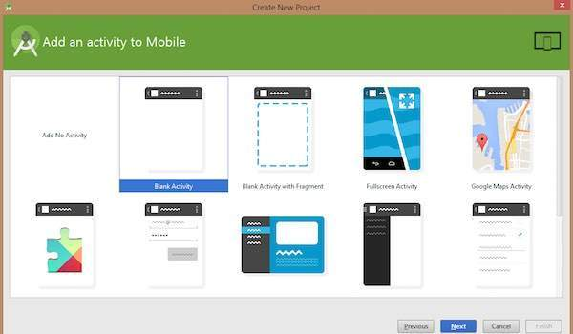

* At the final stage it going to be open development tool to write the application code.

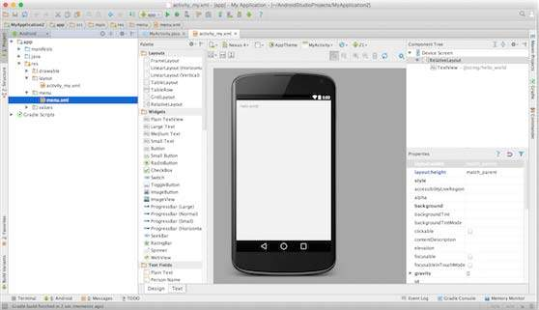**Step 3** - Create Android Virtual Device

* To test your Android applications, you will need a virtual Android device. So before we start writing our code, let us create an Android virtual device. Launch Android AVD Manager Clicking AVD_Manager icon as shown below

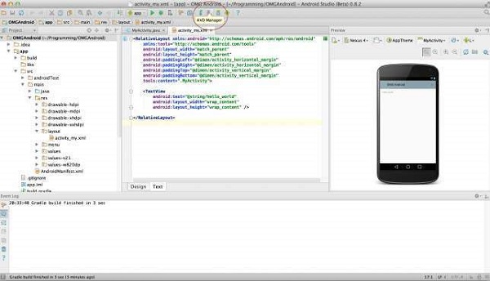

* After Click on a virtual device icon, it going to be shown by default virtual devices which are present on your SDK, or else need to create a virtual device by clicking Create new Virtual device button

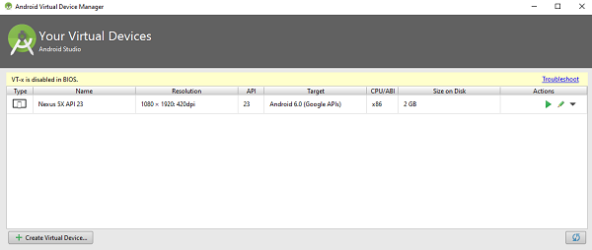

* If your AVD is created successfully it means your environment is ready for Android application development. If you like, you can close this window using top-right cross button. Better you re-start your machine and once you are done with this last step, you are ready to proceed for your first Android example but before that we will see few more important concepts related to Android Application Development.

**3.3 Content diagram of Project**

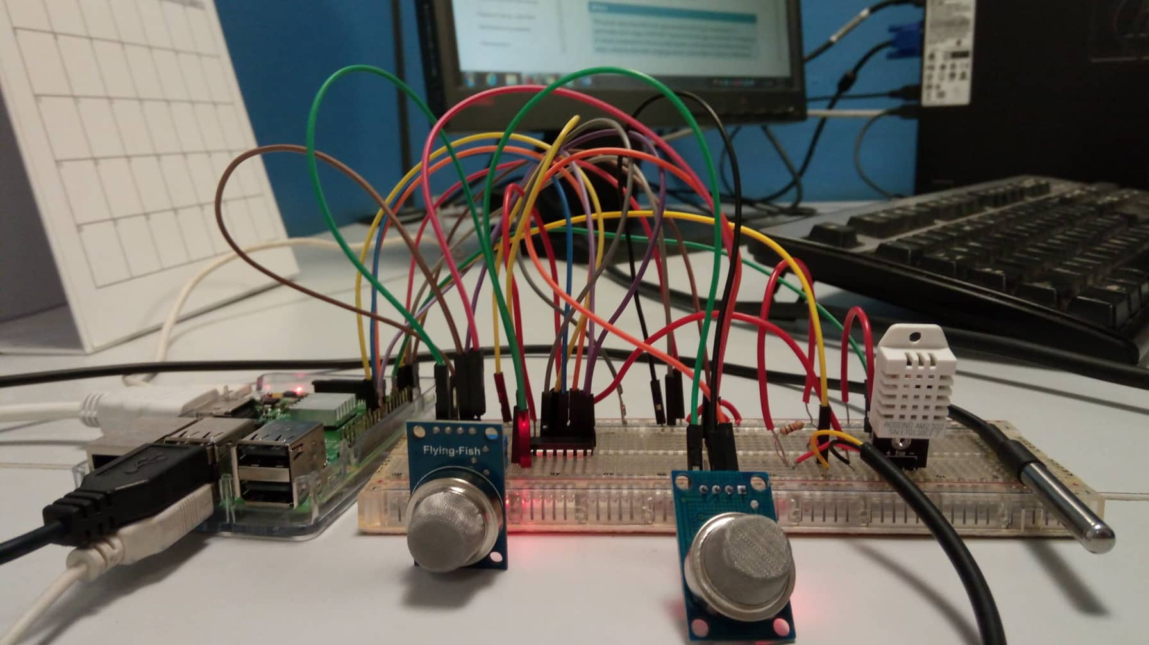

# **CHAPTER 4 DESIGN**

**4.1 Introduction**

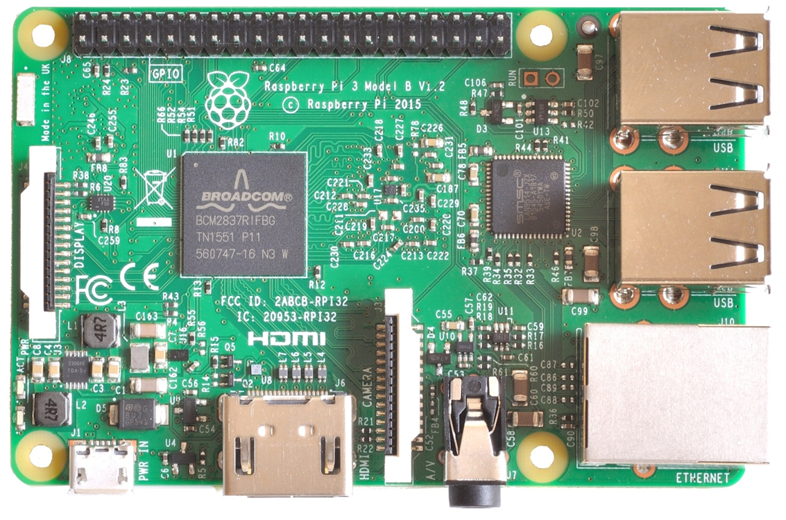

Fig (1): Raspberry pi 3

**4.2 UML Diagram**

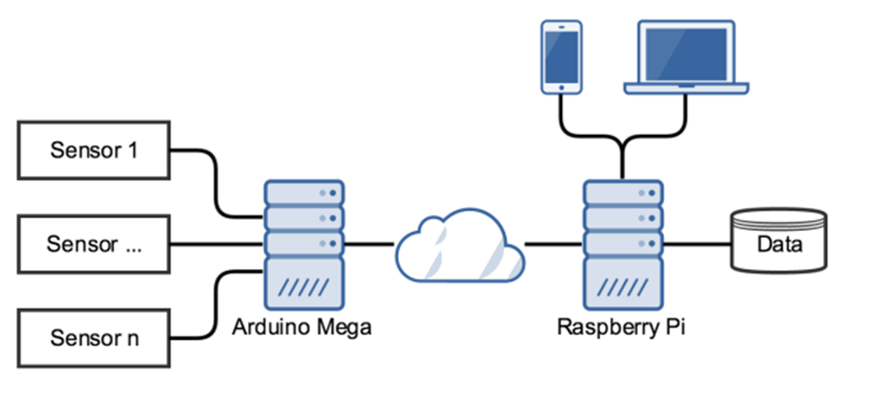

**4.3 Module design and Organization**

Indoor air quality (IAQ) in I-BEAM refers to the quality of the air inside buildings as represented by concentrations of pollutants and thermal (temperature and relative humidity) conditions that affect the health, comfort and performance of occupants. Other factors affecting occupants, such as light and noise, are important indoor environmental quality considerations, but are not treated in I-BEAM as core elements of indoor air quality.

WHAT CAN CONNECTED HOME CAN DO?

* Increase your independence and give you greater control of your home environment.
* Make easier to communicate with your Family.
* Save your time and effort.
* Improve your personal safety.
* It can decrease your Electricity usage.
* It will alert you in Emergency situations.
* It will allow to monitor your home when you are away from home also.
* It will increase the energy efficiency of your home.

**HOW CAN WE CONTROL THEM?**

**REMOTE CONTROL**

**Remote control gives the convenience of controlling the temperatures of our hose with a single device. We can control them from any were from the house and also from outside of the house. There are several methods of Remote controls.**

**AUTOMATIC CONTROL**

**Automatic control is nothing but the things are operated by automatically. We can fix the timings for on and off so it will automatically perform actions. Automatic control adds even more convenience by things happen automatically. We can use any method to control the temperatures.**

**Features:**

* **Control temperatures**
* **Security and personal safety of our home.**

**4.4 Conclusion**

Assessing the health risks of indoor air pollution is very difficult as indoor air may contain over 900 different chemicals, particles and biological materials with potential health effects.

Also, many different factors influence air quality, for example ventilation, cleaning conditions, properties of buildings, products used in households, cultural habits, climate and outdoor environment. Therefore, large variations in indoor environments can be expected across the EU.

The European Commission Scientific Committee on Health and Environmental Risks ([SCHER](http://ec.europa.eu/health/scientific_committees/opinions_layman/en/indoor-air-pollution/glossary/pqrs/scher.htm)) concludes the following:

* The principles used in the EU for [risk assessment](http://ec.europa.eu/health/scientific_committees/opinions_layman/en/indoor-air-pollution/glossary/pqrs/risk-assessment.htm) of chemicals should also be applied to health risk assessment of pollutants in indoor environments.
* The information available to [assess the risk](http://ec.europa.eu/health/scientific_committees/opinions_layman/en/indoor-air-pollution/glossary/pqrs/risk-assessment.htm) of indoor air is in general limited. More data are needed, particularly on health effects of particles and microbes, levels of exposure, and effects of indoor pollutants on [vulnerable](http://ec.europa.eu/health/scientific_committees/opinions_layman/en/indoor-air-pollution/glossary/tuv/vulnerability-health-science.htm) [populations](http://ec.europa.eu/health/scientific_committees/opinions_layman/en/indoor-air-pollution/glossary/pqrs/population-population-group.htm). Several gaps in knowledge have been identified (see Question 9) and should be addressed by European-wide multidisciplinary research.
* [Carbon monoxide](http://ec.europa.eu/health/scientific_committees/opinions_layman/en/indoor-air-pollution/glossary/abc/carbon-monoxide.htm), [formaldehyde](http://ec.europa.eu/health/scientific_committees/opinions_layman/en/indoor-air-pollution/glossary/def/formaldehyde.htm), [benzene](http://ec.europa.eu/health/scientific_committees/opinions_layman/en/indoor-air-pollution/glossary/abc/benzene.htm), [nitrogen oxides](http://ec.europa.eu/health/scientific_committees/opinions_layman/en/indoor-air-pollution/glossary/mno/nitrogen-oxides-nox-nitric-oxide-no-nitrogen-dioxide-no2.htm) and [naphthalene](http://ec.europa.eu/health/scientific_committees/opinions_layman/en/indoor-air-pollution/glossary/mno/naphthalene.htm) are [compounds](http://ec.europa.eu/health/scientific_committees/opinions_layman/en/indoor-air-pollution/glossary/abc/compound.htm) of particular concern because they have caused adverse health effects as indoor pollutants or have a high potential to do so. [Environmental tobacco smoke](http://ec.europa.eu/health/scientific_committees/opinions_layman/en/indoor-air-pollution/glossary/pqrs/secondhand-tobacco-smoke.htm), [radon](http://ec.europa.eu/health/scientific_committees/opinions_layman/en/indoor-air-pollution/glossary/pqrs/radon.htm), [lead](http://ec.europa.eu/health/scientific_committees/opinions_layman/en/indoor-air-pollution/glossary/jkl/lead.htm) and [organophosphates](http://ec.europa.eu/health/scientific_committees/opinions_layman/en/indoor-air-pollution/glossary/mno/organophosphatepesticides.htm) are also of concern.
* Data on true exposure to [volatile organic compounds](http://ec.europa.eu/health/scientific_committees/opinions_layman/en/indoor-air-pollution/glossary/tuv/volatile-organic-compound-voc.htm) emitted by numerous consumer products is insufficient to establish a link with possible health effects because of the many [confounding factors](http://ec.europa.eu/health/scientific_committees/opinions_layman/en/indoor-air-pollution/glossary/abc/confounding-factor.htm). Some of these emitted substances may react in air and on surfaces and produce [secondary pollutants](http://ec.europa.eu/health/scientific_committees/opinions_layman/en/indoor-air-pollution/glossary/pqrs/primary-pollutant-secondary-pollutant.htm) such as [fine](http://ec.europa.eu/health/scientific_committees/opinions_layman/en/indoor-air-pollution/glossary/def/fine-particles-ultrafine-particles.htm) and ultrafine particles whose health effects are poorly understood.

More research is needed to understand how humidity and [mould](http://ec.europa.eu/health/scientific_committees/opinions_layman/en/indoor-air-pollution/glossary/mno/mould.htm) problems in buildings can affect health and to evaluate the seriousness of the problem in EU countries.

The [SCHER](http://ec.europa.eu/health/scientific_committees/opinions_layman/en/indoor-air-pollution/glossary/pqrs/scher.htm) also recommends the following:

Gathering more data on combined effects of indoor pollutants, which are so far limited.

Considering all possible [routes of exposure](http://ec.europa.eu/health/scientific_committees/opinions_layman/en/indoor-air-pollution/glossary/pqrs/route-of-exposure-exposure-route-exposure-pathway.htm) (through [inhalation](http://ec.europa.eu/health/scientific_committees/opinions_layman/en/indoor-air-pollution/glossary/ghi/inhalation-inhale.htm), [ingestion](http://ec.europa.eu/health/scientific_committees/opinions_layman/en/indoor-air-pollution/glossary/ghi/ingestion-ingest.htm), or through the skin) when assessing the risks.

Developing health-based guideline values for key pollutants and other practical guidance in general to help risk management.

Collecting and systematizing practical experiences to establish evidence-based [risk assessment](http://ec.europa.eu/health/scientific_committees/opinions_layman/en/indoor-air-pollution/glossary/pqrs/risk-assessment.htm) approaches.

Considering the impact of indoor exposure when evaluating the health effects of outdoor air pollution, given that concentrations of air pollutants are usually higher indoors and that people tend to spend more time indoors.

Evaluating all relevant sources known to contribute to indoor air pollution, such as tobacco smoke, candles and open fires, building materials, furniture, pets and pests, use of household products, and conditions that [lead](http://ec.europa.eu/health/scientific_committees/opinions_layman/en/indoor-air-pollution/glossary/jkl/lead.htm) to the growth of [moulds](http://ec.europa.eu/health/scientific_committees/opinions_layman/en/indoor-air-pollution/glossary/mno/mould.htm).

# **CHAPTER 5 IMPLEMENTATION AND RESULTS**



**5.1 Introduction**

. The Aim of this is to provide a comprehensive overview on Connected Home Environment with a focus on their architectures and application areas, as well as utilized technologies, infrastructures, and standards. The connected home provides an environment in which an individual can achieve a positive and enhanced state of mind.

Internet means connecting a computer to any other computer anywhere in the world via dedicated routers and servers. Smart home technology gives you ultimate control over your home for in by automating for instance the lighting system, dimming, electrical appliances, and audio and security systems. Over the last two decades technological innovations have transformed the way that we engage with people, products and services and generally how we experience our lives. But little has changed with how we engage with our homes, our primary place of comfort, well-being, financial security and a significant driver of our lifestyles.

Connected Home visions only became technically feasible with the spread of recent development in information and communication technologies related to Cloud Computing, embedded systems, machine learning, and artificial intelligence. Home Automation systems with new Smart functions has high-level goals of well-being like increasing comfort, reducing operational costs, and guaranteeing safety for the house holders.

A Home Automation System that contains a set of home appliances. They are electric and electronic de-vices that fulﬁl several functions in the house for the well-being of the house holders, including for example washing and cooking machines, refrigerators, heaters, thermometers, lighting system, power windows and doors, air conditioners, video cameras, sound detectors, Their functions can be roughly divided into sensors, actuators or both. More advanced “smart de-vices “are constantly being developed, like for example: smart ﬂoors and smart furniture.

**5.2 Implementation of project**

HARDWARE REQURIMENTS

* Raspberry pi
* Sensors
* Bread board
* Connecting wires

SOFTWARE REQURIMENTS

* Rasbian
* MQTT
* Java JDK
* Android studio
* Emulator

RASPBERRY PI

* The purpose of pi was to create a low-cost device that would improve programming skills and hardware understanding at the pre-university level.
* It is a credit-card sized computer designed for education.
* The Raspberry Pi is slower than a modern laptop or desktop but is still a complete Linux computer and can provide all the expected abilities that implies, at a low-power consumption level
* The Raspberry pi is a series of small single service board computers developed in United Kingdom by Raspberry pi foundation to promote the teaching of basic computer science in schools and developing countries.
* The original model became far more popular than anticipated, selling outside its target market for uses such as Robotics. It does not include peripherals such keyboard, mouse, and cases.
* However some accessories have been included in several official and unofficial bundles.

**HARDWARE OF RASPBERRI PI**

The Raspberry Pi hardware has evolved through several versions that feature variations in memory capacity and peripheral-device support.

This block diagram depicts Models A, B, A+, and B+. Model A, A+, and the Pi Zero lack the Ethernet and USB hub components. The Ethernet adapter is internally connected to an additional USB port. In Model A, A+, and the Pi Zero, the USB port is connected directly to the system on a chip On the Pi 1 Model B+ and later models the USB/Ethernet chip contains a five-point USB hub, of which four ports are available, while the Pi 1 Model B only provides two. On the Pi Zero, the USB port is also connected directly to the SoC, but it uses a micro USB (OTG) port.

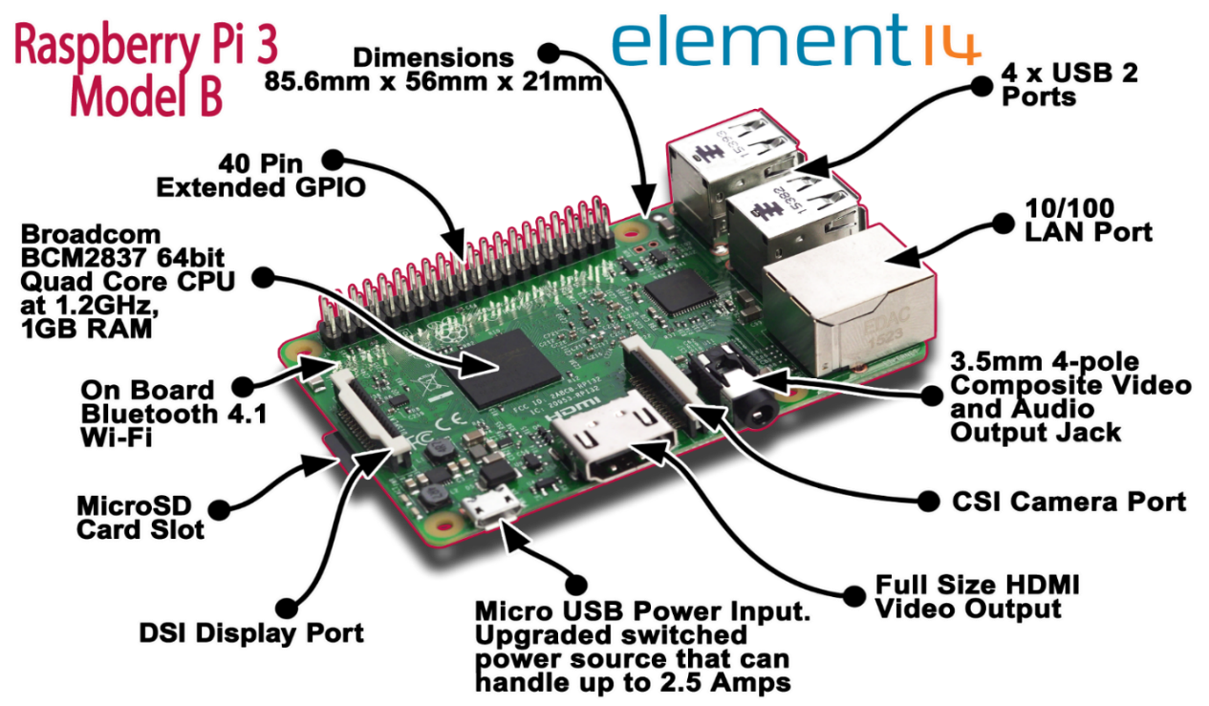

**SENSORS**

* MQ-2
* MQ135
* MCP3008 A TO D CONVERTER
* DS18B20 TEMPERATURE SENSOR ON TEMP
* DHT22 FOR TEMPERATURE N HUMIDITY

**MQ-2** (Methane, Butane, LPG, smoke)

The Grove - Gas Sensor (MQ2) module is useful for gas leakage detection (home and industry). It is suitable for detecting H2, LPG, CH4, CO, Alcohol, Smoke or Propane. Due to its high sensitivity and fast response time, measurement can be taken as soon as possible. The sensitivity of the sensor can be adjusted by potentiometer.

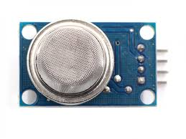

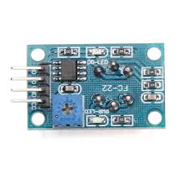

**Features**

* Wide detecting scope
* Stable and long lifetime
* Fast response and High sensitivity

**Application Ideas**

* Gas leakage detection.
* Toys.

**Hardware Overview**

This is an Analog output sensor. It needs to be connected to any one Analog socket in Grove base shield. The examples used in this tutorial make uses of A0 analog pin. Connect this module to the A0 port of Base Shield. The output voltage from the Gas sensor increases when the concentration of gas increases. Sensitivity can be adjusted by rotating the potentiometer. Please note that the best preheat time for the sensor is above 24 hours. For detail information about the MQ-2 sensor, please refer the data-sheet provided in **Resources** section.

Connection between MQ-2 and Raspberry Pi

In this example, we use a 5V voltage as output. This is too much for the GPIOs, which is why we use a logic level converter (TTL) that cuts down the voltage. If you use a sensor other than the MQ-2 and it has a different voltage, the setup must of course be adjusted.

After the MCP3008 is correctly connected, we use port 0 and connect it to RX0 of the TTL. On the opposite side is RX1, which is connected to the analog pin (A0) of the MQ2 sensor. Also connect 3.3V from the Raspberry Pi (LV) and 5V (HV) to the TTL. And also 5V to the VCC pin of the gas sensor and GND from the Raspberry Pi comes to GND on the LV and HV side of the TTL, as well as to GND of the MQ2.

I use the 5V of the Raspberry Pi’s. However, an external power supply is recommended if other sensors and modules or input devices (keyboard, mouse, and touch screen) are used. For this, the sensor is simply supplied with current from the external source (HV side of the TTL) and the ground connection (Minus / GND) is connected to GND of the Raspberry Pi. All MQ-X sensors return analogue signals, which we cannot easily read at the Raspberry Pi. One possibility would be to use an Arduino, but we can also use an analog-to-digital converter (ADC), which can be read out via the I2C bus. In addition, we also need a logic level converter. Details on the individual Raspberry Pi gas sensors can also be found in the corresponding data sheets. Simply [google](https://www.google.com/#q=datasheet+mq-2+filetype:pdf) the name of the sensor including “datasheet”. There is also the voltage at which the sensor operates mentioned. If someone wants to build an alcohol tester or something similar, you should also be aware that these modules are not absolutely accurate and cannot compete with a professional measurement.

Calibration of the Raspberry Pi Gas Sensor -Code

Enough of the theory – we want to use the sensor now. For this purpose you can use the code I have customized, which is located in a GitHub repository. Also included is a class for reading the MCP3008. First we clone the directory:

git clone https://github.com/tutRPi/Raspberry-Pi-Gas-Sensor-MQ

Then we change to the directory and run the existing Python test file.

Cd Raspberry-Pi-Gas-Sensor-MQ

sudo python example.py

The calibration is started automatically during initialization. It is important that the sensor is in good / fresh air as smoke / other gases would falsify the calibration. The process takes a few

Configuration



Structure and configuration of MQ-2 gas sensor is shown as Fig. 3, sensor composed by micro AL2O3 ceramic tube, Tin Dioxide (SnO2) sensitive layer, measuring electrode and heater are fixed into a crust made by plastic and stainless steel net. The heater provides necessary work conditions for work of sensitive components. The enveloped MQ-2 have 6 pin, 4 of them are used to fetch signals, and other 2 are used for providing heating current.

**Character**

* Good sensitivity to Combustible gas in wide range
* High sensitivity to LPG, Propane and Hydrogen
* Long life and low cost
* Simple drive circuit

**Features**

* Wide detecting scope
* Stable and long lifetime
* Fast response and High sensitivity

**Application Ideas**

* Gas leakage detection.
* Industrial Combustible gas detector
* Portable gas detector

**Sensitivity Characteristics**



Fig.1 shows the typical sensitivity characteristics ofthe MQ-2, ordinate means resistance ratio of the sensor **(**Rs/Ro**),** abscissa is concentration of gases. Rs means **resistance** in different gases, Ro means resistance of sensor in 1000ppm Hydrogen. All test are under standard test conditions

**Influence of Temperature/Humidity**

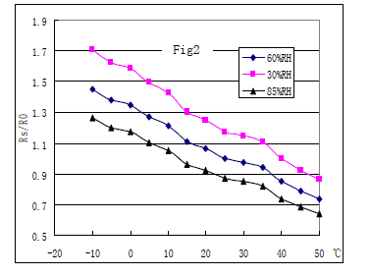

Fig.2 shows the typical temperature and humidity characteristics. Ordinate means resistance ratio of the sensor (Rs/Ro), Rs means resistance of sensor in 1000ppm Butane under different temperature and humidity Ro means resistance of the sensor in environment of 1000ppm Methane, 20℃/65%RH.

**Hardware Overview**

This is an Analog output sensor. It needs to be connected to any one Analog socket in Grove base shield. The examples used in this tutorial make uses of A0 analog pin. Connect this module to the A0 port of Base Shield. The output voltage from the Gas sensor increases when the concentration of gas increases. Sensitivity can be adjusted by rotating the potentiometer. Please note that the best preheat time for the sensor is above 24 hours. For detail information about the MQ-2 sensor, please refer the data-sheet provided in **Resources** section.

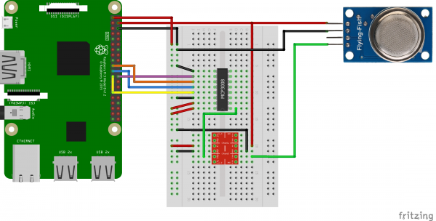

**MQ-135**

**APPLICATION**

They are used in air quality control equipment’s for buildings/offices, are suitable for detecting of NH3,NOx, alcohol, Benzene, smoke,CO2 ,etc.

Sensitive material of MQ135 gas sensor is SnO2, which with lower conductivity in clean air. When the target combustible gas exist, the sensors conductivity is higher along with the gas concentration rising. Please use simple electro circuit, Convert change of conductivity to correspond output signal of gas concentration. MQ135 gas sensor has high sensitity to Ammonia, Sulfide and Benze steam, also sensitive to smoke and other harmful gases. It is with low cost and suitable for different application. Used for family, Surrounding environment noxious gas detection device, Apply to ammonia, aromatics, sulfur, benzene vapor, and other harmful gases/smoke, gas detection, tested concentration range: 10 to 1000ppm.

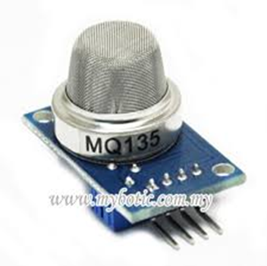

**Specification**

* Working voltage: DC 5V
* Working Current: 150mA
* DOUT: TTL output
* AOUT: Analog output
* Preheat time: Over 20s
* Dimension: 32mm x 22m x 27mm(HIGH 27mm)

**FEATURES**

* Wide detecting scope Fast response and High sensitivity
* Stable and long life Simple drive circuit.

**Accessories**

All MQ-135 sensors return analogue signals, which we can not easily read at the Raspberry Pi. One possibility would be to use an Arduino, but we can also use an analog-to-digital converter (ADC), which can be read out via the I2C bus. In addition, we also need a logic level converter.

* Analog-Digital Converter (8 Ports)
* 5V to 3.3V Logic Level Converter
* Breadboard
* Jumper wire

**DS18B20**

The DS18B20 Digital Thermometer provides 9 to 12-bit (configurable) temperature readings which indicate the temperature of the device. The DS18B20 communicates over a 1-Wire bus that by definition requires only one data line (and ground) for communication with a central microprocessor. In addition, the DS18B20 can derive power directly from the data line (“parasite power”), eliminating the need for an external power supply. This sensor has been included in many applications such as Thermostatic Controls, Industrial Systems, Consumer Products, Thermometers, and Thermally Sensitive Systems.

**Features**

**Pinout of DS18B20**

* Power supply range is 3.0V to 5.5V
* Measures temperatures from -55°C to +125°C. Fahrenheit equivalent is -67°F to +257°F
* ±0.5°C accuracy from -10°C to +85°C
* Converts 12-bit temperature to digital word in 750 ms (max.)
* Can be powered from data line
* Alarm search command identifies and addresses devices whose temperature is outside of programmed limits (temperature alarm condition)

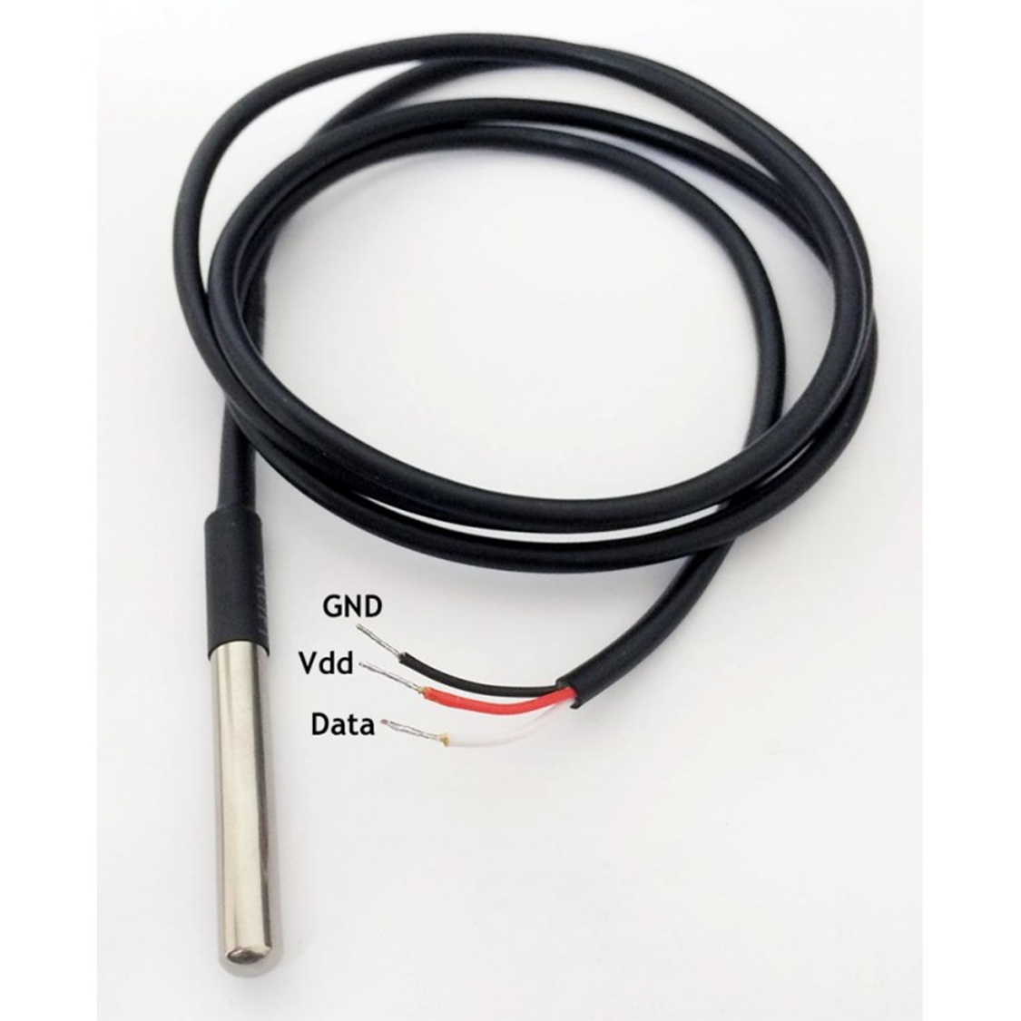

**Working Principle of DS18B20 Temperature Sensor**

The core functionality of the DS18B20 is its direct-to-digital temperature sensor. The resolution of the temperature sensor is user-configurable to 9, 10, 11, or 12 bits, corresponding to increments of 0.5°C, 0.25°C, 0.125°C, and 0.0625°C, respectively. The default resolution at power-up is 12-bit. The DS18B20 powers up in a low power idle state. To initiate a temperature measurement and A-to-D conversion, the master must issue a Convert T [44h] command. Following the conversion, the resulting thermal data is stored in the 2-byte temperature register in the scratchpad memory and the DS18B20 returns to its idle state. If the DS18B20 is powered by an external supply, the master can issue “read time slots” after the Convert T command and the DS18B20 will respond by transmitting 0 while the temperature conversion is in progress and 1 when the conversion is done.

**CONNECTION BETWEEN DA18B20 AND RASPBERRY PI**

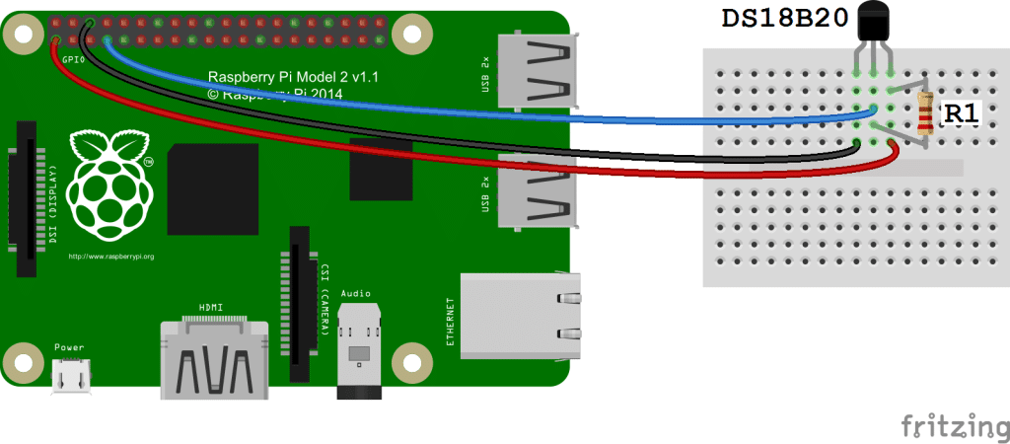

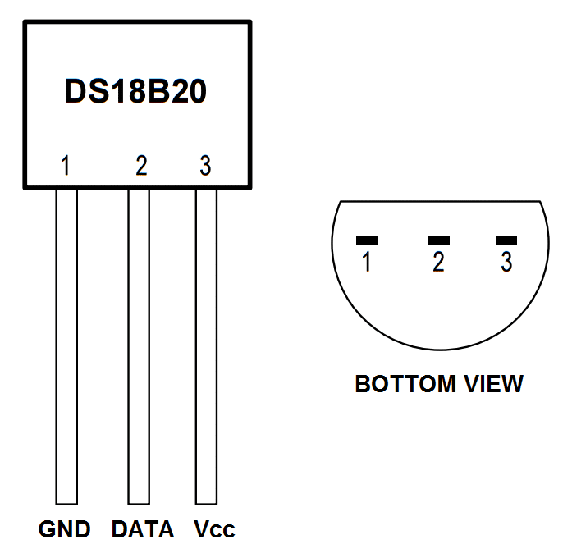

**DHT22 FOR TEMPERATURE AND HUMIDITY**

The DHT22 is a basic, low-cost digital temperature and humidity sensor. It uses a capacitive humidity sensor and a thermistor to measure the surrounding air, and spits out a digital signal on the data pin (no analog input pins needed). It's fairly simple to use, but requires careful timing to grab data. The only real downside of this sensor is you can only get new data from it once every 2 seconds, so when using our library, sensor readings can be up to 2 seconds old.

**Technical Details**

* Low cost
* 3 to 5V power and I/O
* 2.5mA max current use during conversion (while requesting data)
* Good for 0-100% humidity readings with 2-5% accuracy
* Good for -40 to 80°C temperature readings ±0.5°C accuracy
* No more than 0.5 Hz sampling rate (once every 2 seconds)
* Body size 27mm x 59mm x 13.5mm (1.05" x 2.32" x 0.53")
* 4 pins, 0.1" spacing
* Weight (just the DHT22): 2.4g

**5.3 Method of Implementation**

**MQTT**

MQTT (MQ Telemetry Transport)

MQTT (MQ Telemetry Transport) is a lightweight messaging protocol that provides resource-constrained network clients with a simple way to distribute [telemetry](http://whatis.techtarget.com/definition/telemetry)information. The protocol, which uses a publish/subscribe communication pattern, is used for machine-to-machine ([M2M](http://internetofthingsagenda.techtarget.com/definition/machine-to-machine-M2M)) communication and plays an important role in the internet of things ([IoT](http://internetofthingsagenda.techtarget.com/definition/Internet-of-Things-IoT)).

Network clients with a simple way to distribute [telemetry](http://whatis.techtarget.com/definition/telemetry)information. The protocol, which uses a publish/subscribe communication pattern, is used for machine-to-machine ([M2M](http://internetofthingsagenda.techtarget.com/definition/machine-to-machine-M2M)) communication and plays an important role in the internet of things ([IoT](http://internetofthingsagenda.techtarget.com/definition/Internet-of-Things-IoT)).

MQTT enables resource-constrained IoT devices to send, or publish, information about a given topic to a server that functions as an MQTT [message broker](http://whatis.techtarget.com/definition/message-broker). The broker then [pushes](http://whatis.techtarget.com/definition/push-or-server-push) the information out to those clients that have previously subscribed to the client's topic. To a human, a topic looks like a hierarchical file path. Clients can subscribe to a specific level of a topic's hierarchy or use a [wild-card character](http://whatis.techtarget.com/definition/wildcard-character) to subscribe to multiple levels.

The MQTT protocol is a good choice for wireless networks that experience varying levels of [latency](http://whatis.techtarget.com/definition/latency) due to occasional [bandwidth](http://searchenterprisewan.techtarget.com/definition/bandwidth) constraints or unreliable connections. Should the connection from a subscribing client to a broker get broken, the broker will buffer messages and push them out to the subscriber when it is back online. Should the connection from the publishing client to the broker be disconnected without notice, the broker can close the connection and send subscribers a cached message with instructions from the publisher.

**Analog to Digital Converter MCP3008**

The MCP3008 is a low cost 8-channel 10-bit analog to digital converter.  The precision of this ADC is similar to that of an Arduino Uno, and with 8 channels you can read quite a few analog signals from the Pi.  This chip is a great option if you just need to read simple analog signals, like from a MQ2 sensor.

**Features**

* 10-bit resolution
* ± 1 LSB max DNL
* ± 1 LSB max INL
* 8 (MCP3008) input channels
* Analog inputs programmable as single-ended or pseudo-differential pairs On-chip sample and hold
* SPI serial interface (modes 0,0 and 1,1)
* Single supply operation: 2.7V - 5.5V
* 200 ksps max. sampling rate at VDD = 5V
* 75 ksps max. sampling rate at VDD = 2.7V
* Low power CMOS technology
* 5 Na typical standby current, 2 μA max.
* 500 μA max. active current at 5V
* Industrial temp range: -40°C to +85°C
* Available in PDIP, SOIC and TSSOP packages

**Block Diagram**

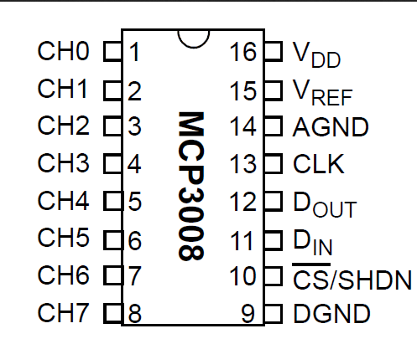

First, connect a 3v3 pin to the positive rail on the breadboard and a ground pin to the ground rail on the breadboard. Also, place the MCP3008 chip into the middle of the breadboard.

* VDD (Pin 16) wire this to 3.3V
* VREF (Pin 15) wire this to 3.3V
* AGND (Pin 14) wire this to ground
* CLK (Pin 13) wire this to GPIO11 (Pin 23/SCLK)
* DOUT (Pin 12) wire this to GPIO9 (Pin 21/MISO)
* DIN (Pin 11) wire this to GPIO10 (Pin 19/MOSI)
* CS (Pin 10) wire this to GPIO8 (Pin 24/CE0)
* DGND (Pin 9) wire this to GROUND

**Azure cloud**

The architecture of cloud computing comprises of the following components − of Cloud Computing

* Front-end device

Cloud computing

The popular trend in today's technology driven world is ‘Cloud Computing’. Cloud computing can be referred to as the storing and accessing of data over the internet rather than your computer's hard drive. This means you don't access the data from either your computer's hard drive or over a dedicated computer network (home or office network). Cloud computing means data is stored at a remote place and is synchronized with other web information.

One prominent example of cloud computing is Office 365 which allows users to store, access, edit their MS Office documents online (in browser) without installing the actual program on their device.

* Architecture Back-end platform
* Cloud-based delivery
* Network

**Front-end Devices** − these are basically the devices that are used by clients to access the data or program using the browser or special applications.

**Back-end Platform** − There are various computers, servers, virtual machines, etc. that combine to become a back-end platform.

Types of Cloud

The storage options on cloud is in 3 forms −

* Public
* Private
* Hybrid

**Public Cloud** − A service provider makes the clouds available to the general public which is termed as a public cloud. These clouds are accessed through internet by users. These are open to public and their infrastructure is owned and operated by service providers as in case of Google and Microsoft.

**Private Cloud** − these clouds are dedicated to a particular organization. That particular organization can use the cloud for storing the company's data, hosting business application, etc. The data stored on private cloud can't be shared with other organizations. The cloud is managed either by the organization itself or by the third party.

**Hybrid Cloud** − When two or more clouds are bound together to offer the advantage of both public and private clouds, they are termed as Hybrid Cloud. Organizations can use private clouds for sensitive application, while public clouds for non-sensitive applications. The hybrid clouds provide flexible, scalable and cost-effective solutions to the organizations.

**Benefits of Cloud**

There are many benefits of clouds. Some of them are listed below.

* Cloud service offers scalability. Allocation and de-allocation of resources is dynamically as per demand.
* It saves on cost by reducing capital infrastructure.
* It allows the user to access the application independent of their location and hardware configuration.
* It simplifies the network and lets the client access the application without buying license for individual machine.
* Storing data on clouds is more reliable as it is not lost easily.

**SPI**

Next comes how cloud services are categorized. S stand for Software, P stands for Platform and I for Infrastructure in SPI. SaaS is Software as a service; PaaS is Platform as a service and IaaS is Infrastructure as a Service.

Following are the live examples of these models.

* SAAS Model − E-mail (Gmail, Yahoo, etc.)
* PAAS Model − Microsoft Azure
* IAAS Model − Amazon S3

**How to connect raspberry pi to Azure cloud:-**

The Storage component of Windows Azure represents a durable store in the cloud. Windows Azure allows developers to store tables, blobs, and message queues. The storage can be accessed through HTTP. You can also create our own client; although Windows Azure SDK provides a client library for accessing the Storage.

In this chapter, we will learn how to create a Windows Azure Storage account and use it for storing data.

## **Creating Azure Storage Account**

**Step 1** − When you login into your Azure account, you can find ‘Storage’ under ‘Data Services’.

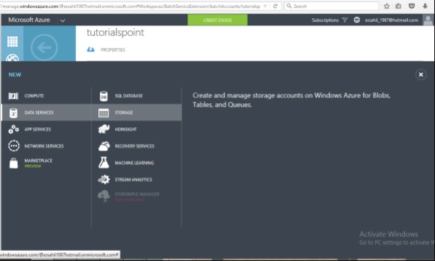

**Step 2** − Click on ‘Quick Create’ and it will ask for ‘Account Name’.

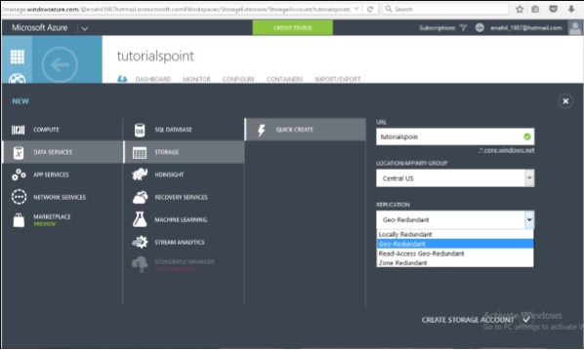

You can see there are four options in the ‘Replication’ dropdown. A copy of the data is kept so that it is durable and available at high speed. It is retained even in case of hardware failure. Let’s see what these options mean −

* **Locally redundant storage** − Copy of the data is created in the same region where storage account is created. There are 3 copies of each request made against the data that resides on separate domains.
* **Zone-redundant storage (available for blobs only)** − Copy of the data is created on separate facilities either in the same region or across two regions. The advantage is that even if there is failure on one facility, the data still can be retained. Three copies of data are created. One more advantage is that data can be read from a secondary location.
* **Geo-redundant storage** − `Copy is created in a different region which means data is retained even if there is a failure in the complete region. The numbers of copies of data created are 6 in this case.
* **Read-access geo-redundant storage** − this option allows reading of data from a secondary location when data on the primary location is not available. The number of copies created is 6. The main advantage here is that availability of data can be maximized.

There are different price plans for each replication option and the ‘Local Redundant’ is the cheapest of them all. So, choosing the replication of data depends on the cost and individual requirements.

## **Storage Account Endpoints**

**Step 1** − Click on the ‘Storage Account’ it will take you to the next screen.

**Step 2** − Click on ‘Dashboard’ from top horizontal menu.

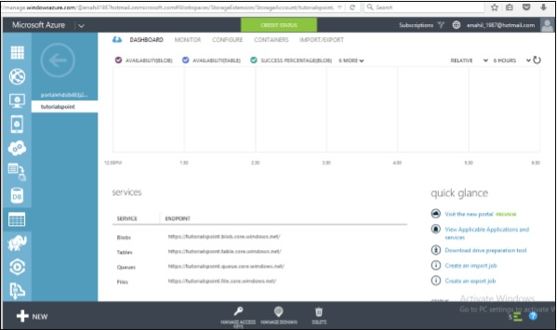

Here you can see four items under services. You can create blobs, tables, queues and files in this storage account.

There will a unique URL for each object. For example, here account name is ‘tutorials point’ then the default URL for blob is similarly, replace blob with table, queue and file in the URL to get the respective URLs. To access an object in the location is appended in the URL. For example,

## **Generating an Access Key**

Access key is used to authenticate the access to the storage account. Two access keys are provided in order to access the account without interrupting it, in case, one key has to be regenerated.

To get the Access Keys, click on ‘Manage Access Keys’ in your storage account. The following screen will come up.

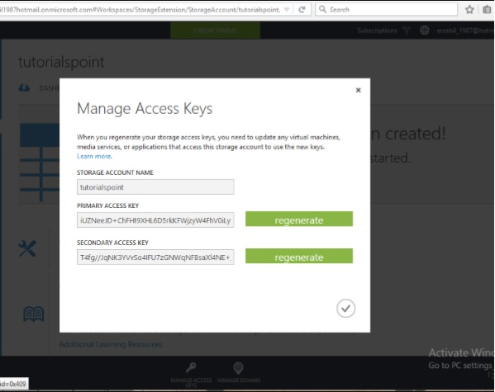

Regenerating the key at regular intervals is advised for security reasons.

Register a device in the IoT hub for your device

1. In the [Azure portal](https://portal.azure.com/), open your IoT hub.
2. Click IoT Devices.
3. In the IoT Devices pane, click Add to add a device to your IoT hub. Then do the following:

Device ID: Enter the ID of the new device. Device IDs are case sensitive.

Authentication Type: Select Symmetric Key.

Auto Generate Keys: Select this check box.

Connect device to IoT Hub: Click Enable.

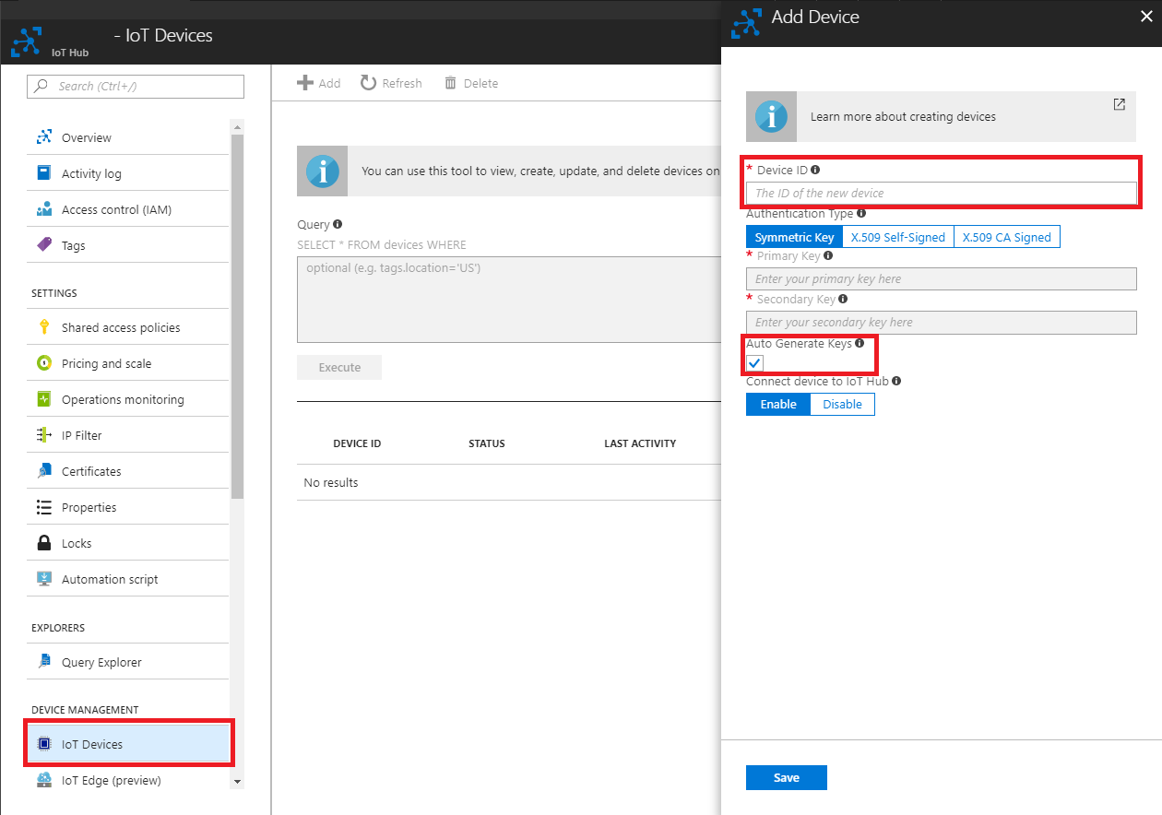

Important

The device ID may be visible in the logs collected for customer support and troubleshooting, so make sure to avoid any sensitive information while naming it.

1. Click Save.
2. After the device is created, open the device in the IoT Devices pane.

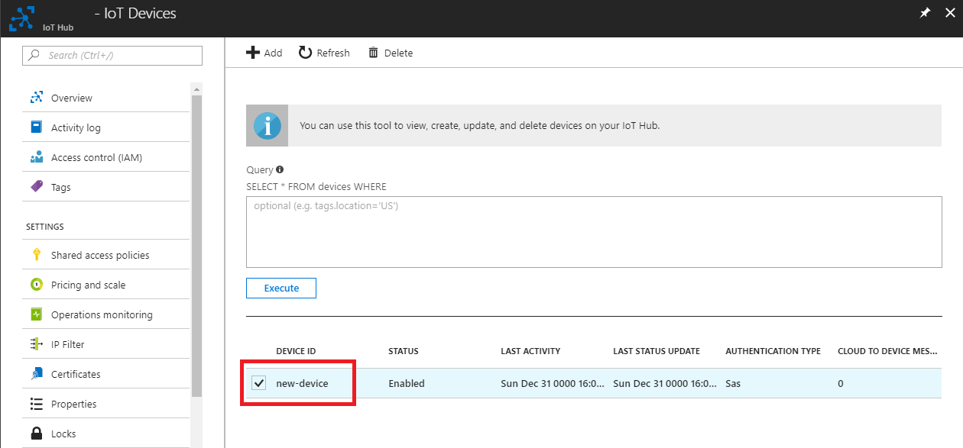

1. Make a note of the primary key of the connection string.

## **Managing Data to Azure Storage**

How can you upload or download data to Azure store? There are many ways to do it, but it can’t be done within the Azure portal itself. You will have to either create your own application or use an already built tool.

There are many tools available for accessing the data in an explorer that can be accessed by clicking on ‘Storage Explorer’ under ‘Get the Tools’ in your Azure storage account. Alternatively, an application can also be built using Software Development Kit (SDK) available in Windows Azure Portal. Using the PowerShell commands is also an option to upload data. PowerShell is a command line application that facilitates administering and managing the Azure storage. Preset commands are used for different tasks to manage the storage.

You can install PowerShell by going to ‘Downloads’ on the following screen in your account. You will find it under Command-Line tools.



There are specific commands for each task. You can manage you storage account, create a new account, and create a container. Additionally, blobs, tables, queues messages can also be managed using PowerShell.

Create IOT hub:-

1. Sign in to the [Azure portal](https://portal.azure.com/).

2. Select Create a resource > Internet of Things > IoT Hub.



1. In the IoT hub pane, enter the following information for your IoT hub:

* Name: Create a name for your IoT hub. If the name you enter is valid, a green check mark appears.

Important

The IoT hub will be publicly discoverable as a DNS endpoint, so make sure to avoid any sensitive information while naming it.

Pricing and scale tier: For this tutorial, select the F1 - Free tier. For more information, see the [Pricing and scale tier](https://azure.microsoft.com/pricing/details/iot-hub/).

Resource group: Create a resource group to host the IoT hub or use an existing one. For more information, see [Use resource groups to manage your Azure resources](https://docs.microsoft.com/en-us/azure/azure-resource-manager/resource-group-portal)

Location: Select the closest location to you.

Pin to dashboard: Check this option for easy access to your IoT hub from the dashboard.

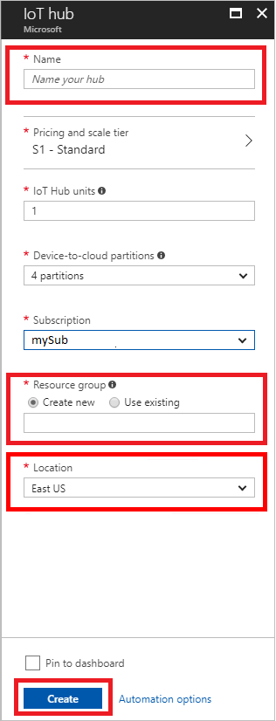

1. Click Create. Your IoT hub might take a few minutes to create. You can monitor the progress in the Notifications pane.

Now that you have created an IoT hub, locate the important information that you use to connect devices and applications to your IoT hub.

1. After your IoT hub is created, click it on the dashboard. Make a note of the Hostname, and then click Shared access policies.

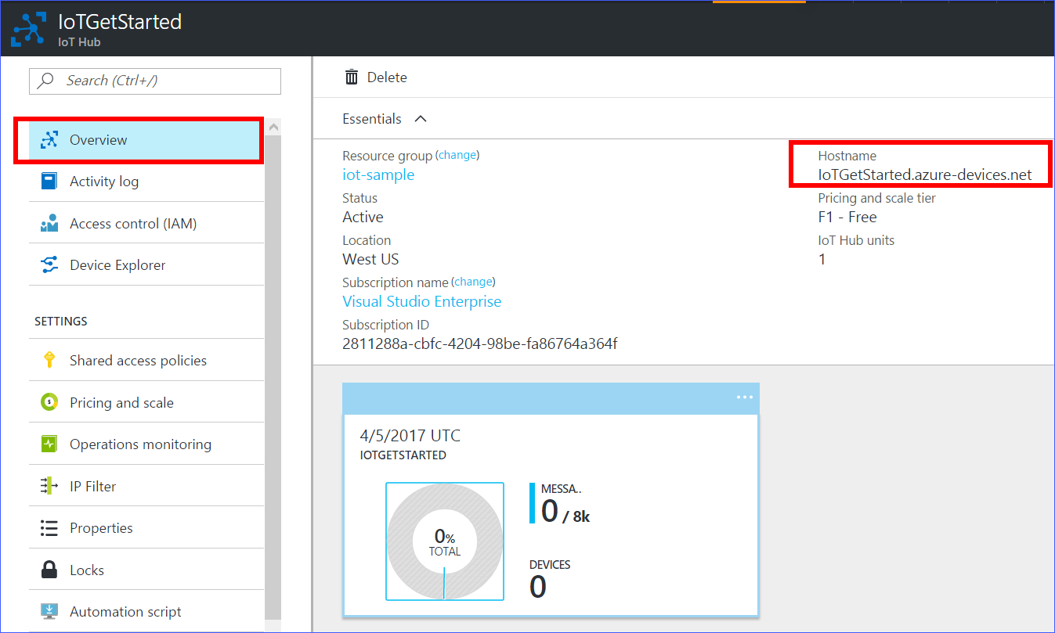

1. In the Shared access policies pane, click the iot hub owner policy, and then copy and make a note of the Connection string of your IoT hub. For more information, see [Control access to IoT Hub](https://docs.microsoft.com/en-us/azure/iot-hub/iot-hub-devguide-security).

Note

You will not need this iot hub owner connection string for this set-up tutorial. However, you may need it for some of the tutorials on different IoT scenarios after you complete this set-up.

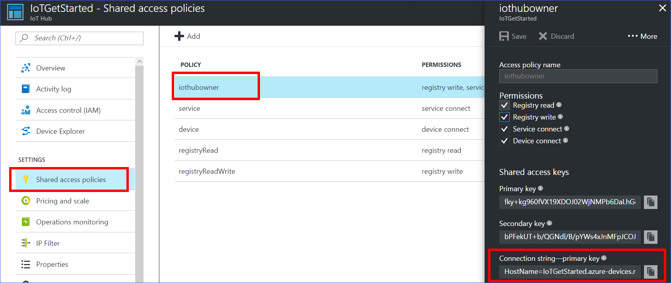

Configure the sample application

1. Clone the sample application by running the following command:

**Cd ~**

Git clone Open the config file by running the following commands:

**Cd iot-hub-python-raspberrypi-client-app**

**nano config.py**

There are 5 macros in this file you can configurate. The first one is Message-Timespan, which defines the time interval (in milliseconds) between two messages that send to cloud. The second one simulated-data, which is a Boolean value for whether to use simulated sensor data or not.I2c-Address is the I2C address which your BME280 sensor is connected. GPIO-PIN-ADDRESS is the GPIO address for your LED. The last one is Blink-span which defined the timespan when your LED is turned on in milliseconds.

If you don't have the sensor, set the SIMULATED-DATA value to true to make the sample application create and use simulated sensor data.

1. Save and exit by pressing Control-O > Enter > Control-X.

Build and run the sample application

1. Build the sample application by running the following command. Because the Azure IoT SDKs for Python are wrappers on top of the Azure IoT Device C SDK, you will need to compile the C libraries if you want or need to generate the Python libraries from source code.

Bash Copy

**Sudo chmod u+x setuo.sh**

**Sudo./setup.sh**

Build and run the sample application

1. Build the sample application by running the following command. Because the Azure IoT SDKs for Python are wrappers on top of the Azure IoT Device C SDK, you will need to compile the C libraries if you want or need to generate the Python libraries from source code.

**sudo chmod u+x setup.sh**

**sudo ./setup.sh**

Run the sample application by running the following command:

Python app.py '<your Azure IoT hub device connection string>'

Android app development: -

Android is an open source and Linux-based Operating System for mobile devices such as smartphones and tablet computers. Android was developed by the *Open Handset Alliance*, led by Google, and other companies.

Android offers a unified approach to application development for mobile devices which means developers need only develop for Android, and their applications should be able to run on different devices powered by Android.

The first beta version of the Android Software Development Kit (SDK) was released by Google in 2007 where as the first commercial version, Android 1.0, was released in September 2008.

The source code for Android is available under free and open source software licenses. Google publishes most of the code under the Apache License version 2.0 and the rest, Linux kernel changes, under the GNU General Public License version 2.

Android applications are usually developed in the Java language using the Android Software Development Kit.

**Set-up Java Development Kit (JDK)**

You can download the latest version of Java JDK from Oracle's Java site − [Java SE Downloads](http://www.oracle.com/technetwork/java/javase/downloads/index.html). You will find instructions for installing JDK in downloaded files, follow the given instructions to install and configure the setup. Finally set PATH and JAVA_HOME environment variables to refer to the directory that contains java and javac, typically java_install_dir/bin and java_install_dir respectively.

If you are running Windows and installed the JDK in C:\jdk1.8.0_102, you would have to put the following line in your C:\autoexec.bat file.

Set PATH=C:\jdk1.8.0-102\bin;%PATH%

Alternatively, you could also right-click on *My Computer*, select *Properties*, then *Advanced*, then *Environment Variables*. Then, you would update the PATH value and press the OK button.

On Linux, if the SDK is installed in /usr/local/jdk1.8.0_102 and you use the C shell, you would put the following code into your **.**cshrc file.

Setenv PATH/usr/local/jdk1.8.0_102/bin:$PATH

Setenv JAVA_HOME/usr/local/jdk1.8.0_102

Alternatively, if you use Android studio, then it will know automatically where you have installed your Java.

**Android IDEs**

There are so many sophisticated Technologies are available to develop android applications, the familiar technologies, which are predominantly using tools as follows

* [Android Studio](https://www.tutorialspoint.com/android/android_studio.htm)
* [Eclipse IDE(Deprecated)](https://www.tutorialspoint.com/android/android_eclipse.htm)
* This app will give information to the user
* This android app will display the information of each sensors and we can able to see the last five values of each sensors.
* The user can able to check the level of gas sensor, Carbon dioxide, smoke, carbon monoxide, temperature and humidity.
* The user can take precautions based on the information of sensors.
* The app will send notifications for LPG and Temperature for the values when it is in normal and medium for every one hour and for critical it will send for every 5 minutes.
* The app contain dashboard of each sensor.
* If user want to see individual sensors data, it can also be possible.

**5.4 Output Screens and Result Analysis**

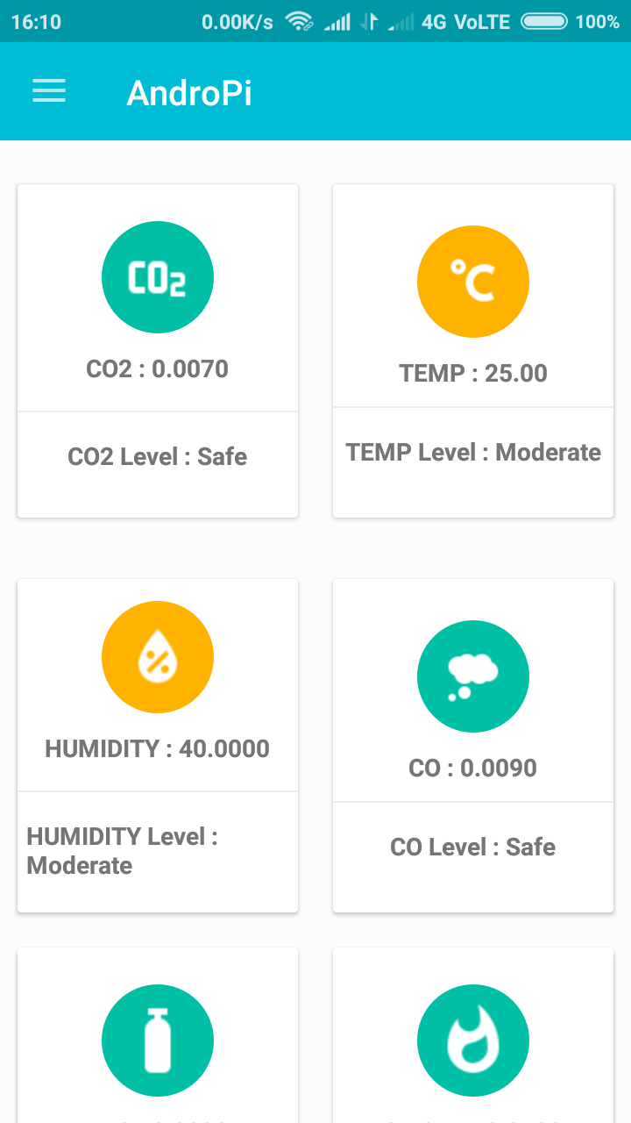

* The home page contains the values and levels of gases like safe, moderate and critical for the gases Co2, Temperature, Humidity, Co, Smoke, LPG.
* The user can able to see all the values of gases in a single graph.
* The graph consist the last five values of Co2, Co, LPG, Smoke

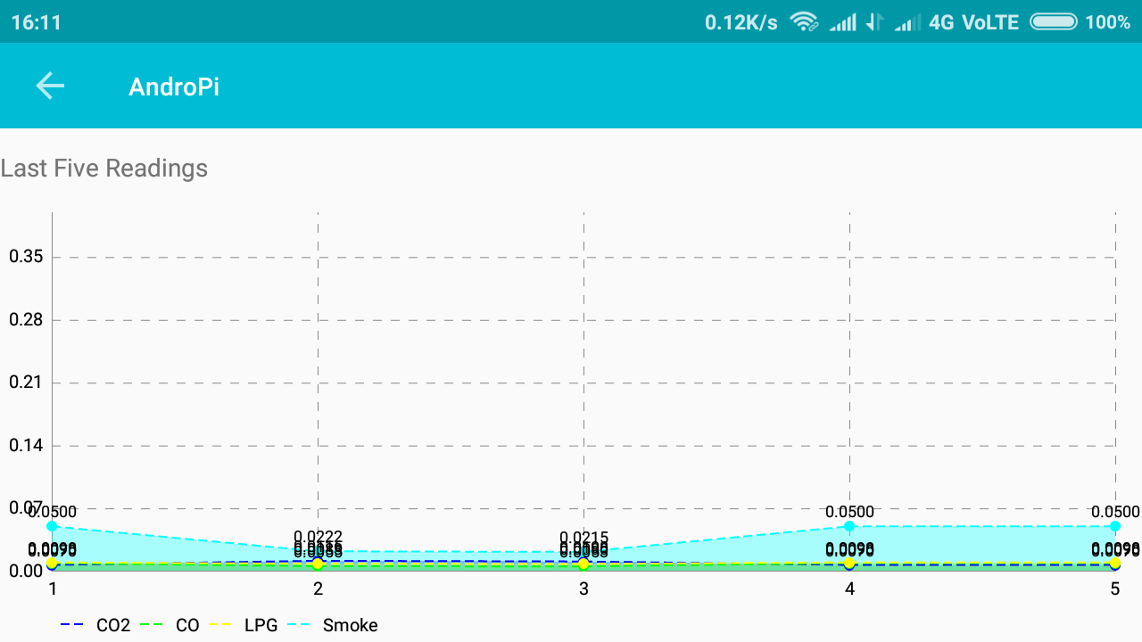

* For user understandable purpose we created separate colors for separate gas such as blue line for Co2, green for Co, Yellow for LPG and Sky blue for Smoke.
* If user want to see individual gas value, we provided each graph for each gas.

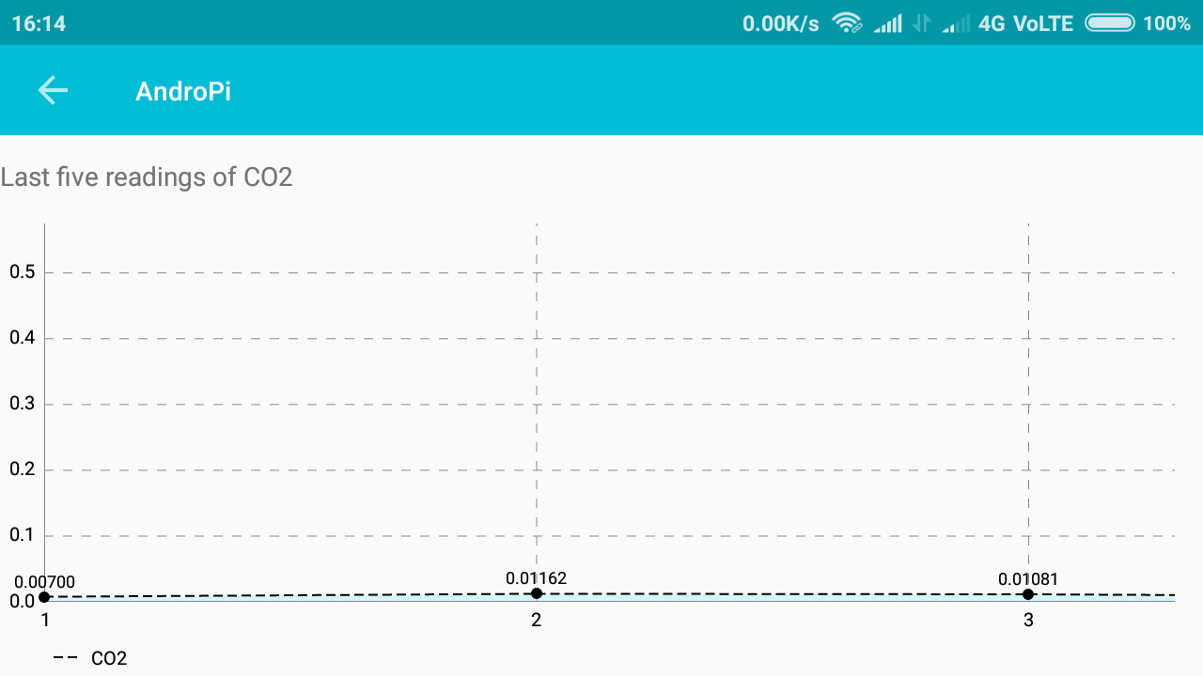

* The above graph shows the last five readings of Co2.
* The dotted black color line shows the values of Co2 such as first value is 0.00700, second value is 0.01162 and third value is 0.01081 and so on.
* In a graph X axis indicates the past five values of Co2 gas and Y axis indicates the five readings of Co2 gas.

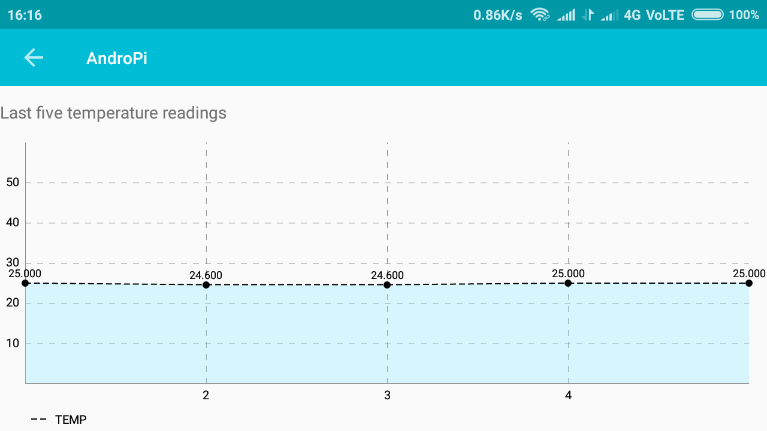

* The above graph indicated the last five readings of temperature
* The black dotted line shows the particular values of temperature such as 25.000, 24.600 and so on.
* In a graph the X axis indicates the last five readings of temperature and Y axis shows the last five values of Temperature.

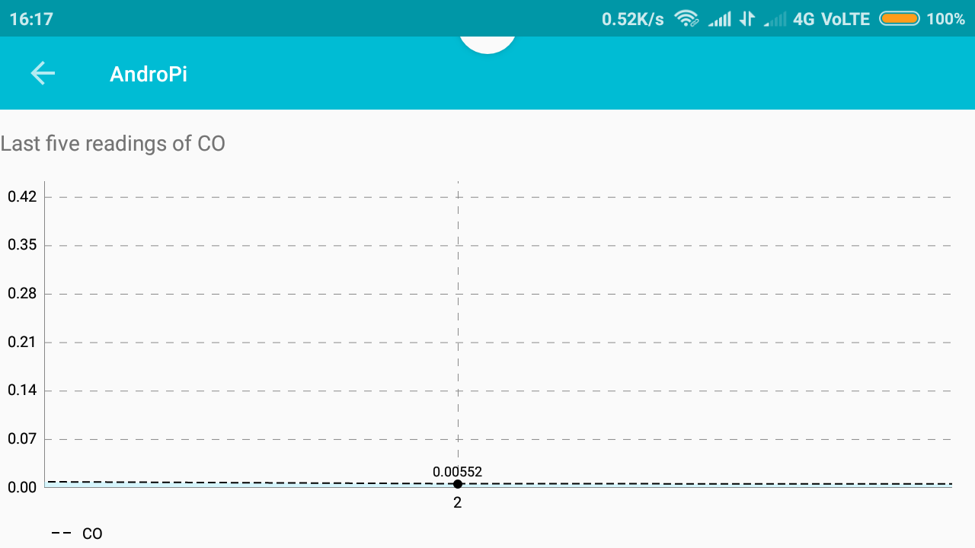

* The above graph indicates about co gas.
* It contains the last five readings of co gas.
* The dotted black color line shows the values of Co such as first value is 0.07, second value is 0.14 and third value is 0.21 and so on.
* In a graph X axis indicates the past five values of Co gas and Y axis indicates the five readings of Co gas.

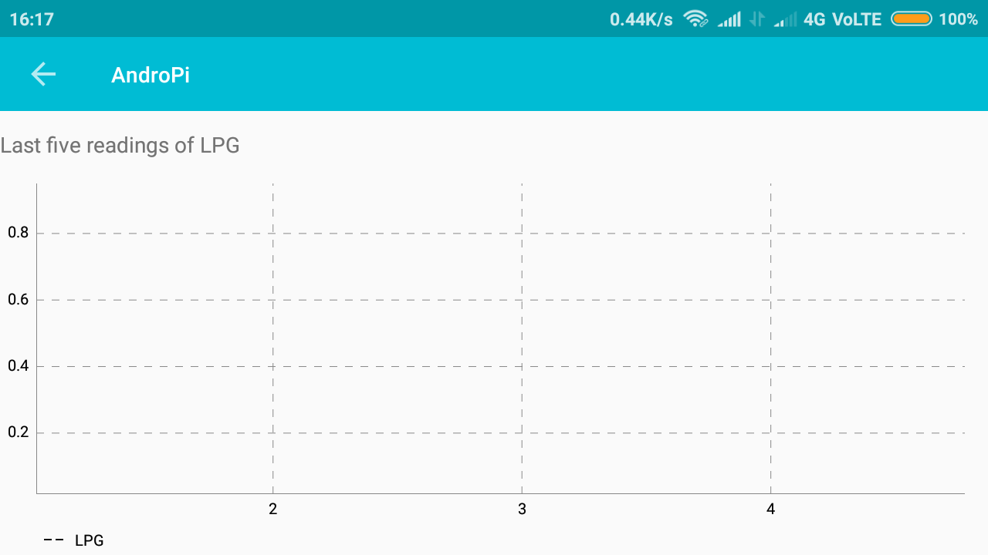

* The above graph indicates about LPG gas.
* It contains the last five readings of LPG gas.
* The dotted black color line shows the values of LPG such as first value is 0.2, second value is 0.4 and third value is 0.6 and so on.
* In a graph X axis indicates the past five values of LPG gas and Y axis indicates the five readings of LPG gas.

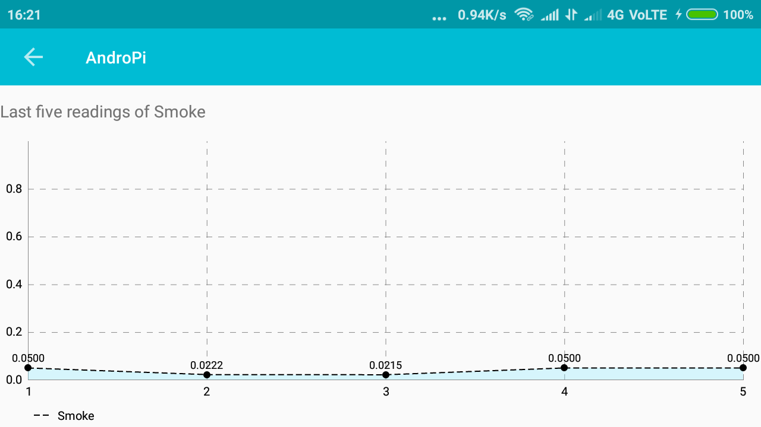

* The above graph indicates about Smoke gas.
* It contains the last five readings of Smoke gas.
* The dotted black color line shows the values of Smoke such as first value is 0.0, second value is 0.2 and third value is 0.4 and so on.
* In a graph X axis indicates the past five values of Smoke gas and Y axis indicates the five readings of LPG gas.

**5.5 Conclusion**

Unvented combustion appliances, especially gas stoves, are major sources of indoor air pollution. Although emission rates from a small number of gas stoves have been determined for several pollutants, the data base is very limited. Indoor concentrations of carbon monoxide and nitrogen dioxide associated with incomplete combustion have been observed to exceed current ambient-air quality standards. Carbon dioxide emission from unvented combustion appliances may build up to concentrations in the range of occupational air quality standards. Local exhaust ventilation appears to be the most effective control strategy for reducing pollutants from combustion. Improved combustion efficiency and source elimination (i.e., adsorbers or a change to the use of electric ranges) are two additional control approaches. Residential wood and coal stoves are also potential sources of indoor contamination. Attached and underground garages can contribute to indoor carbon monoxide, nitrogen dioxide, and particle concentrations.

# **CHAPTER 6 Testing and Validation**

Modern systems must be designed and operated to achieve a proper balance between air quality, thermal comfort and energy consumption. In healthcare premises, ventilation is used extensively in all types of facilities to provide a safe and comfortable environment for patients and staff. Specialised ventilation is provided in primary patient treatment areas such as operating departments, critical care units and in sterile services departments and pharmacies to ensure compliance with quality assurance.

Residential and commercial gaseous air cleaning technologies have not gained wide acceptance in the marketplace, in part due to the lack of performance data from field tests or simulation studies. This paper describes a field study of the performance of two gaseous air cleaners in a single room test house and simulations based on these tests with an indoor air quality model (CONTAMW). Air cleaner effective cleaning rates (ECR) were experimentally measured for toluene and ranged from 93 m3/h to 202 m3/h compared to the average toluene loss rates of 18 m3/h due to infiltration and 7.7 m3/h due to sorption on surfaces in the house. As a result, the effectiveness of the air cleaners for toluene in these tests ranged from 82 % to 94 % for different experimental conditions. CONTAMW proved to be an effective tool for predicting the impact of air cleaner performance in the single zone environment.

**6.1 Introduction**

Multizone indoor air quality (IAQ) modeling has been available as a research and analysis tool for over 20 years.

However, due to improvements in such modeling programs (particularly the development of user-friendly graphic interfaces), the spread of cheap computing power, and more complex building design requirements, the application of such programs has greatly increased and is moving from there search world to a broader audience. This has, in turn, increased the need for establishing the validity of these models. There are two general types of computer simulation techniques for studying airflow and contaminant transporting buildings – zonal modeling and multizone modeling. Zonal (or room airflow) modeling takes a microscopic view of IAQ by applying a computational fluid dynamics (CFD)program to examine the detailed flow fields and pollutant concentration distributions within a room or rooms. A thorough treatment may be found in many textbooks on the subject (such as Anderson et al. 1984) or in a NIST report (Kurabuchi et al. 1990). Multizone airflow and pollutant transport modeling takes macroscopic view of air movement and IAQ by evaluating average pollutant concentrations in the different zones of a building as contaminants are transported through the building and its HVAC system.

Each approach has strengths and limitations for studying different building ventilation and IAQ problems.

The multizone approach is implemented by constructing a network of elements describing the flow paths (HVAC ducts, doors, windows, cracks, etc.) between the zones of a building. The network nodes represent the zones that are modeled at a uniform pressure, temperature, and pollutant concentration. After calculating the airflow between zones and ambient, zonal pollutant concentrations are calculated by applying mass balance equations to the zones that may contain pollutant sources or sinks. A survey of multizone airflow models was described by Feustel and Dieris (1992).

A critical point was made by Herrlin in a general discussion on multizone model validation (Herrlin 1992). Because the number of cases a complex multizone model can simulate are unlimited, an absolute validation is impossible. However, validation efforts are still important to identify and eliminate large errors and to establish the range of applicability of the model. Therefore, a model's performance should be evaluated under a variety of situations. Herrlin also stressed that it is important for users to recognize that a model's predictions will always have a degree of uncertainty.

**6.2 Design of Test cases and Scenarios**

